Which statements, when inserted independently into the following blank, will cause the code to print 2 at runtime?

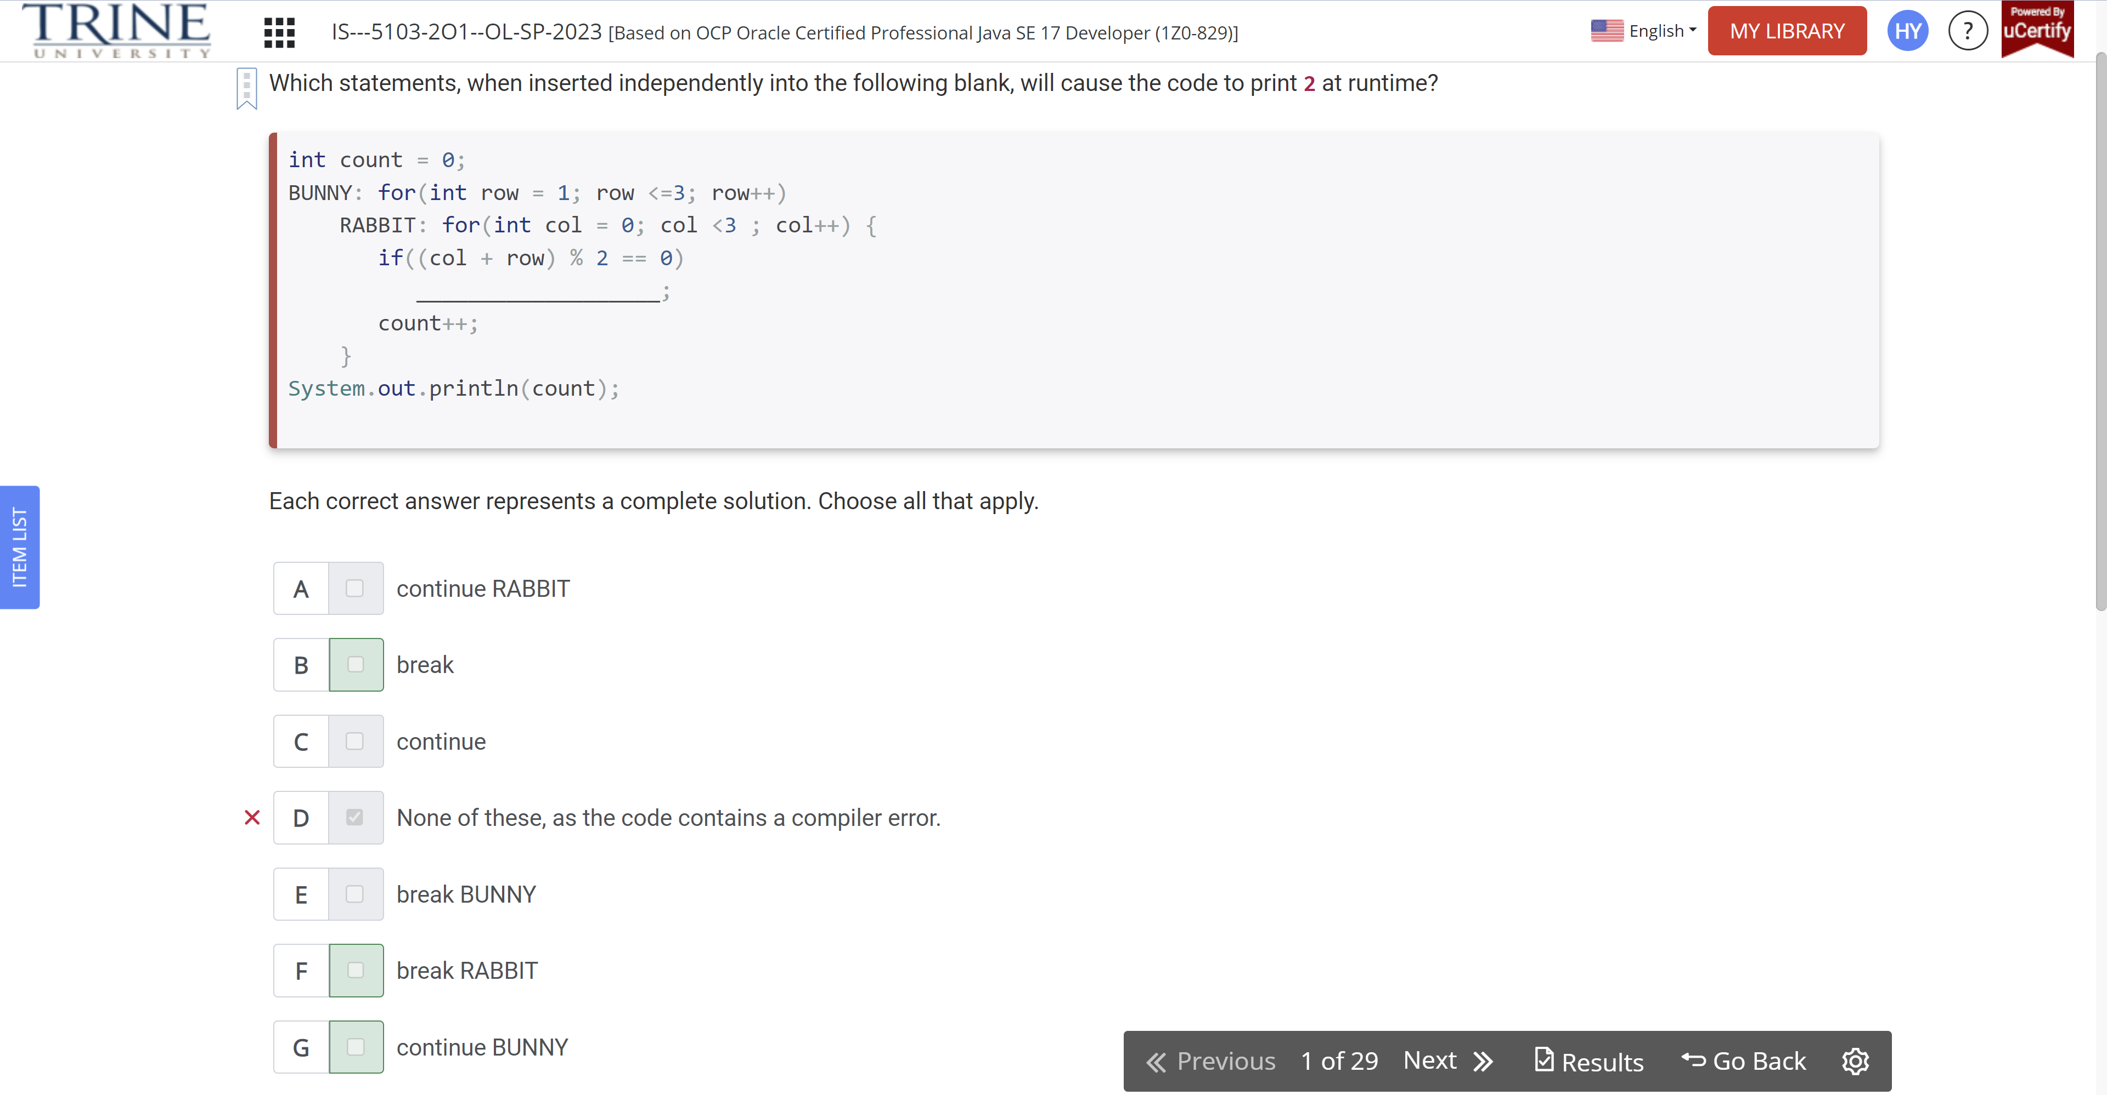

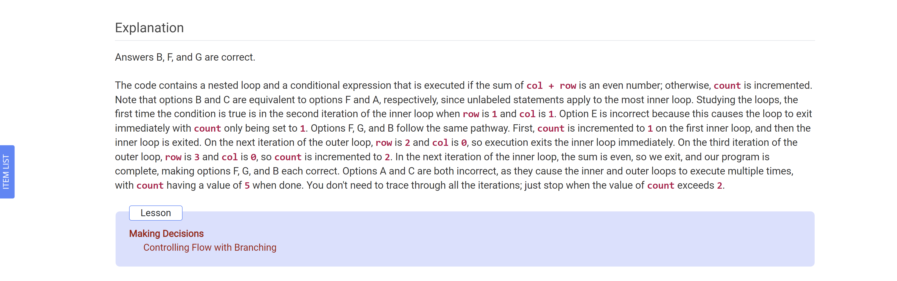

Which statements about the following code snippet are correct?

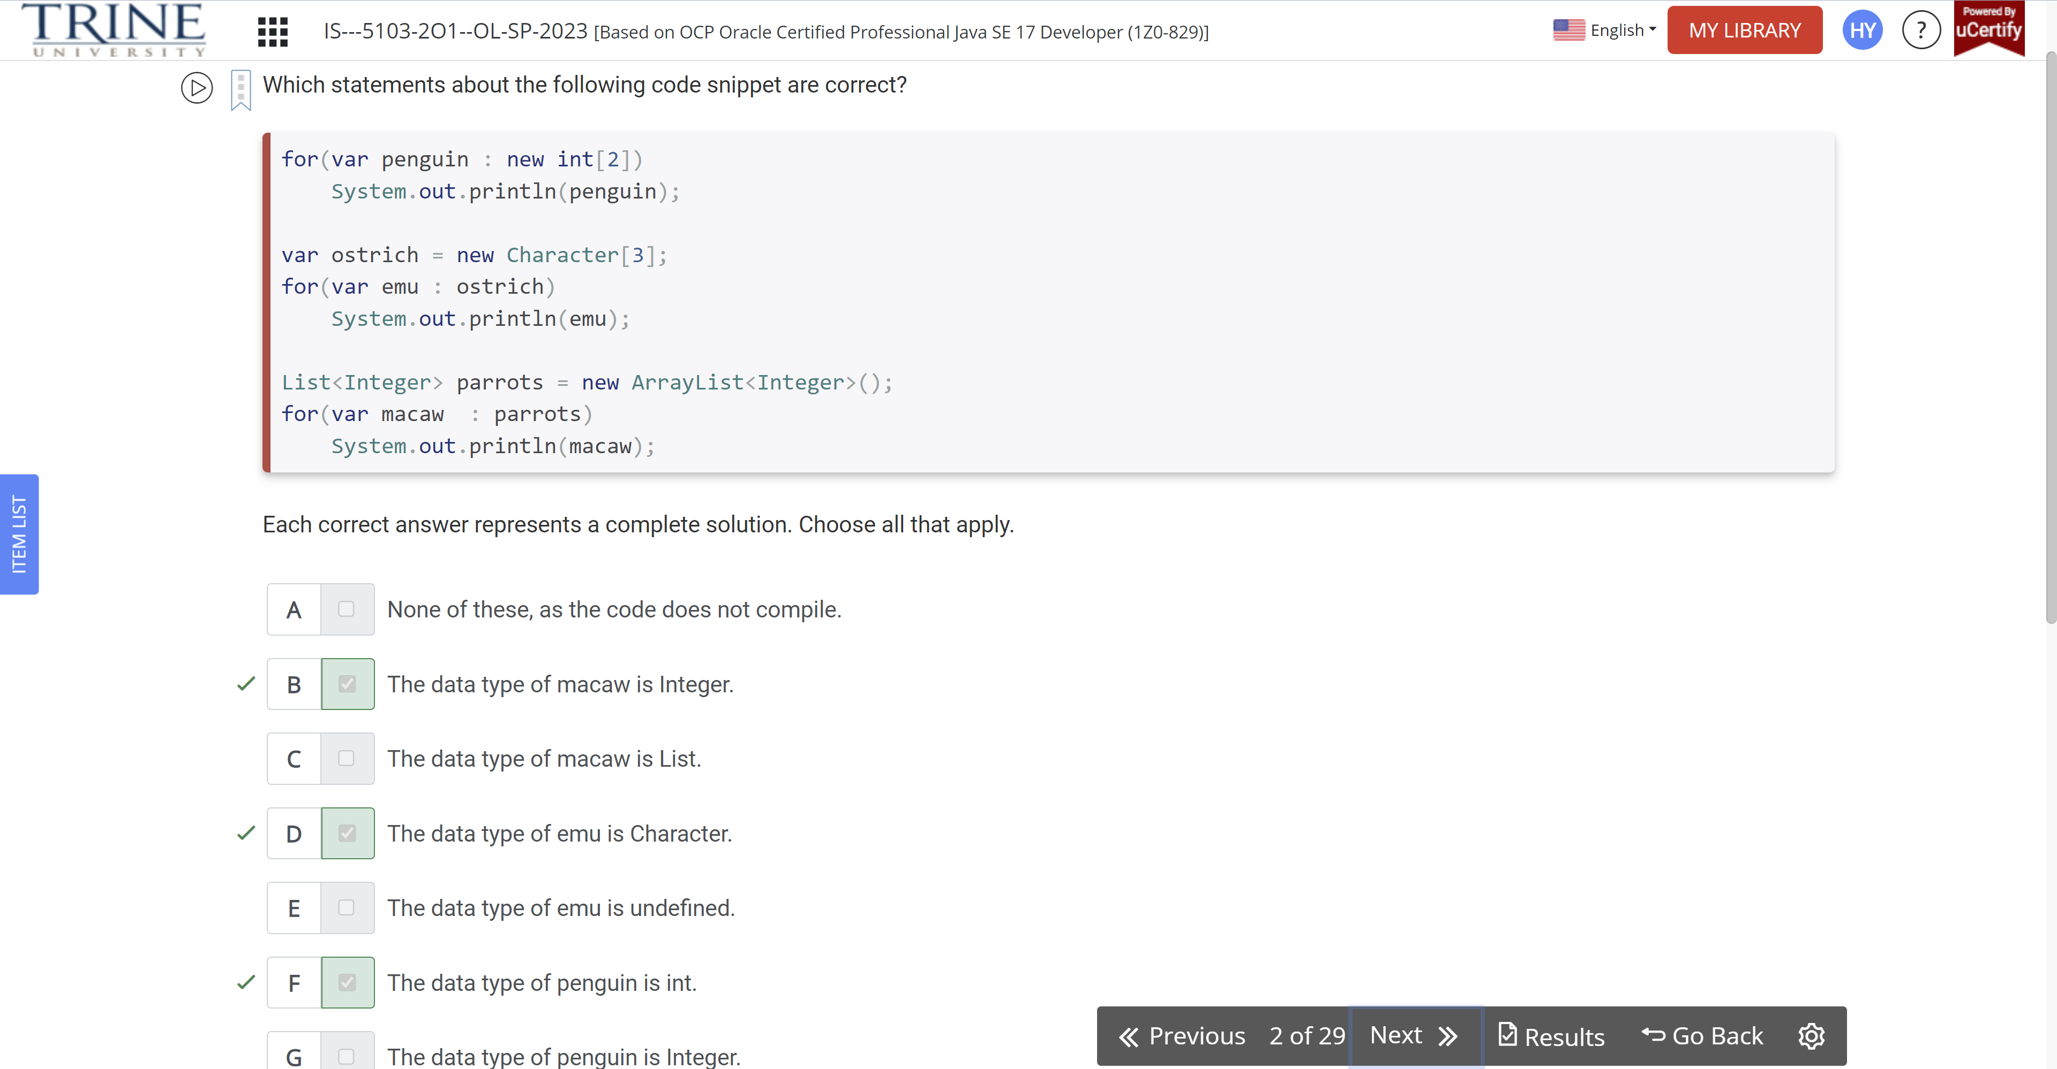

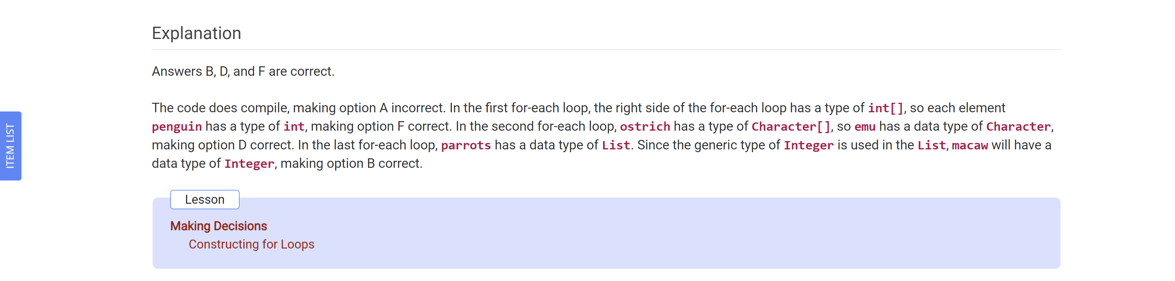

What is the result of the following code?

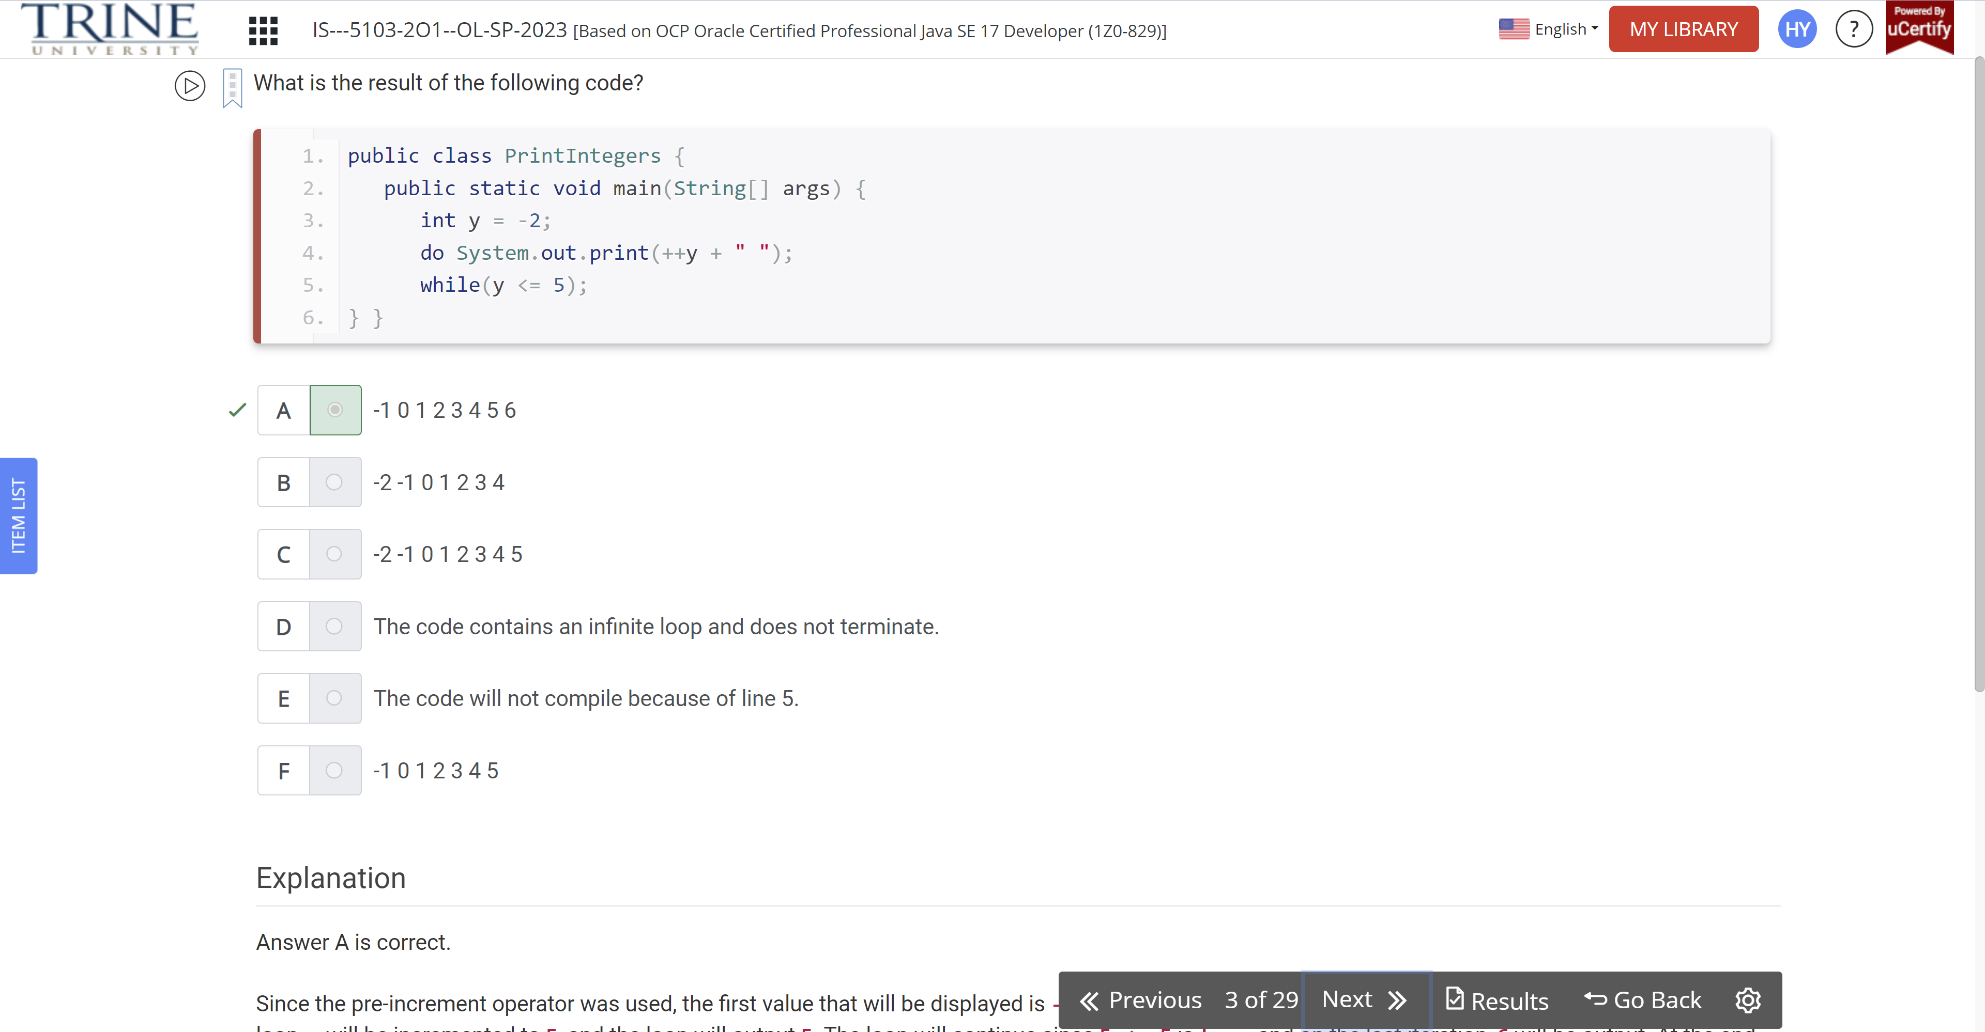

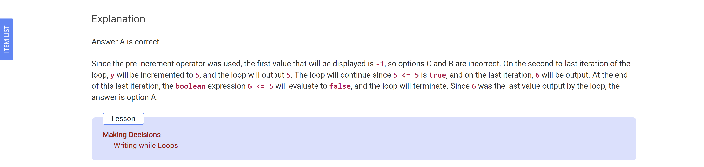

What is the output of the following code snippet?

Double iguana = 0;

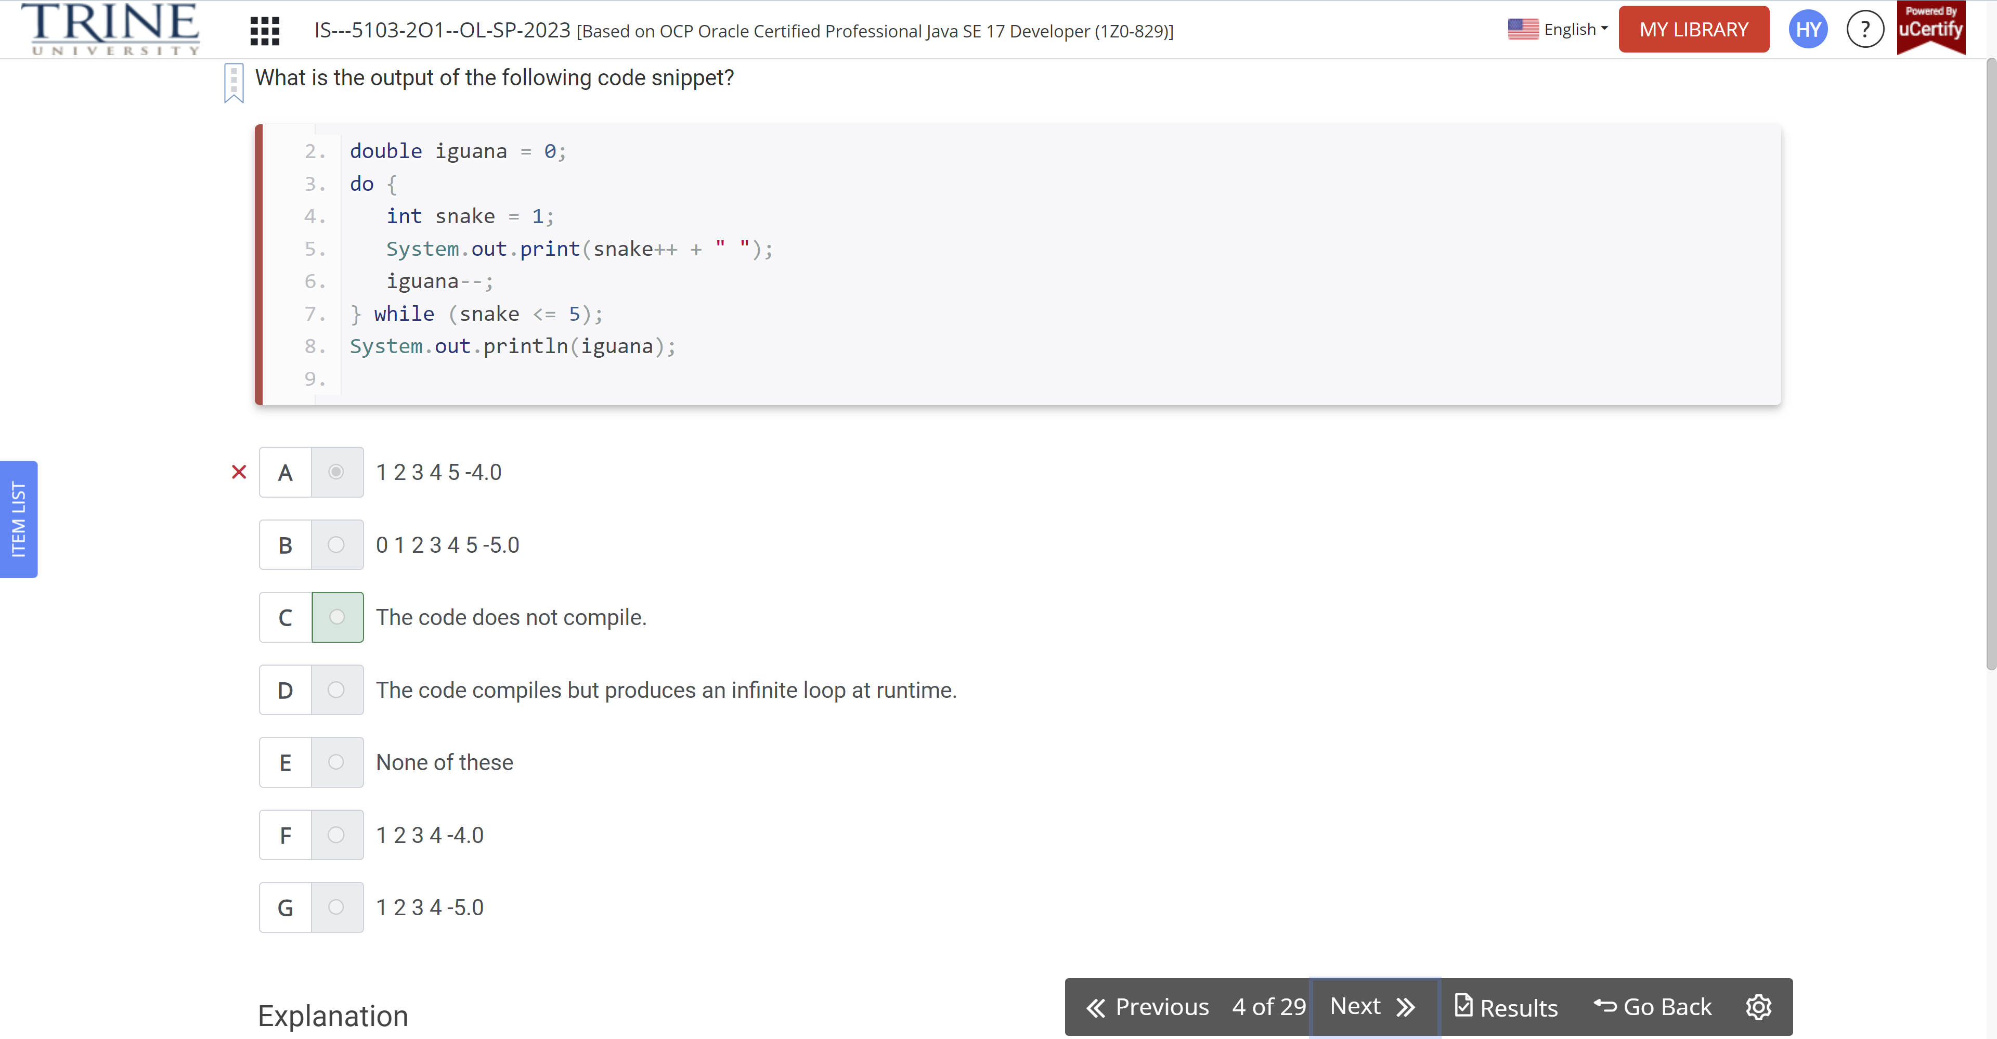

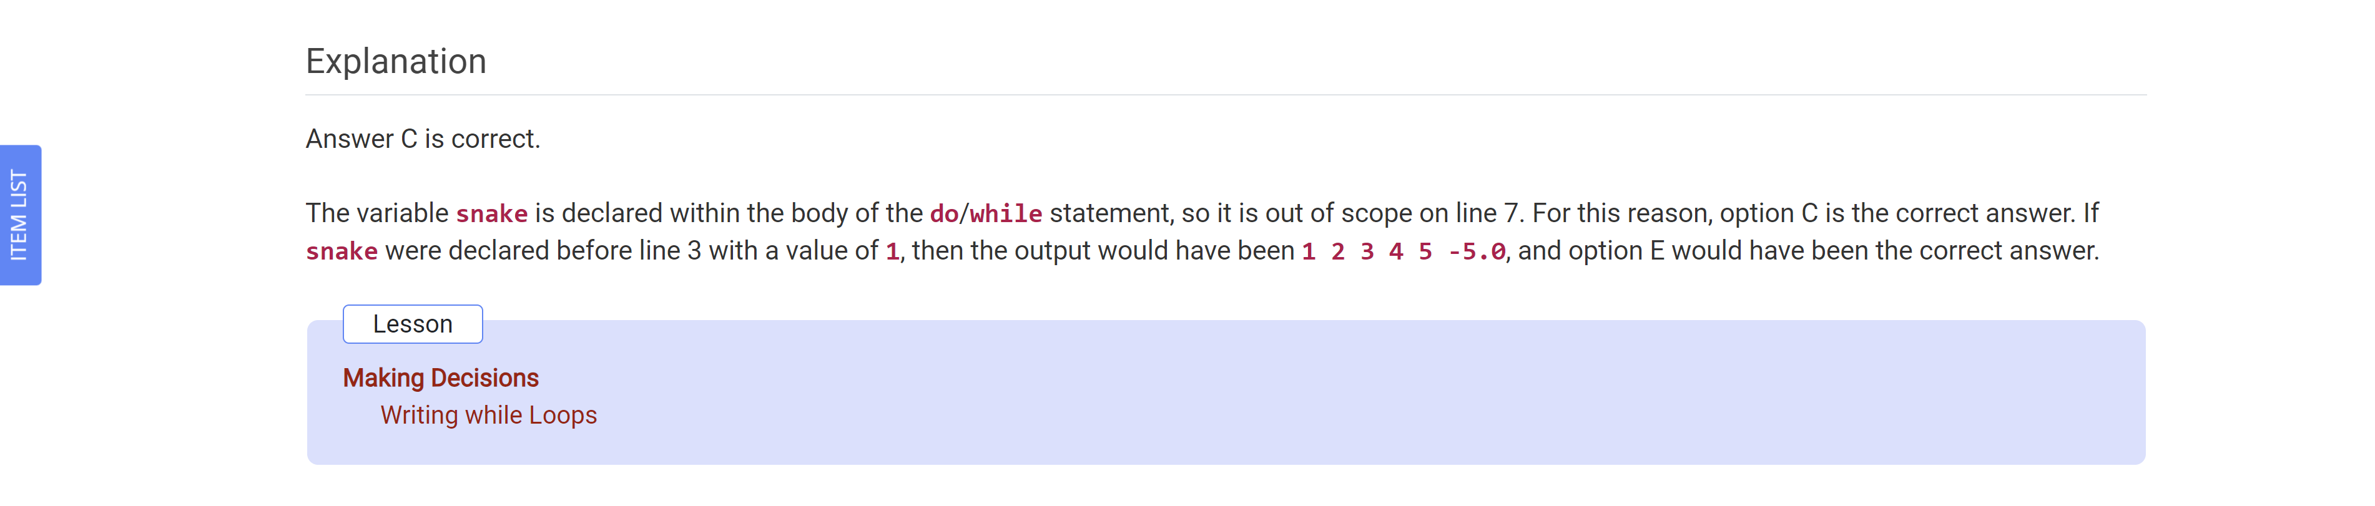

What is the output of calling printType(11)?

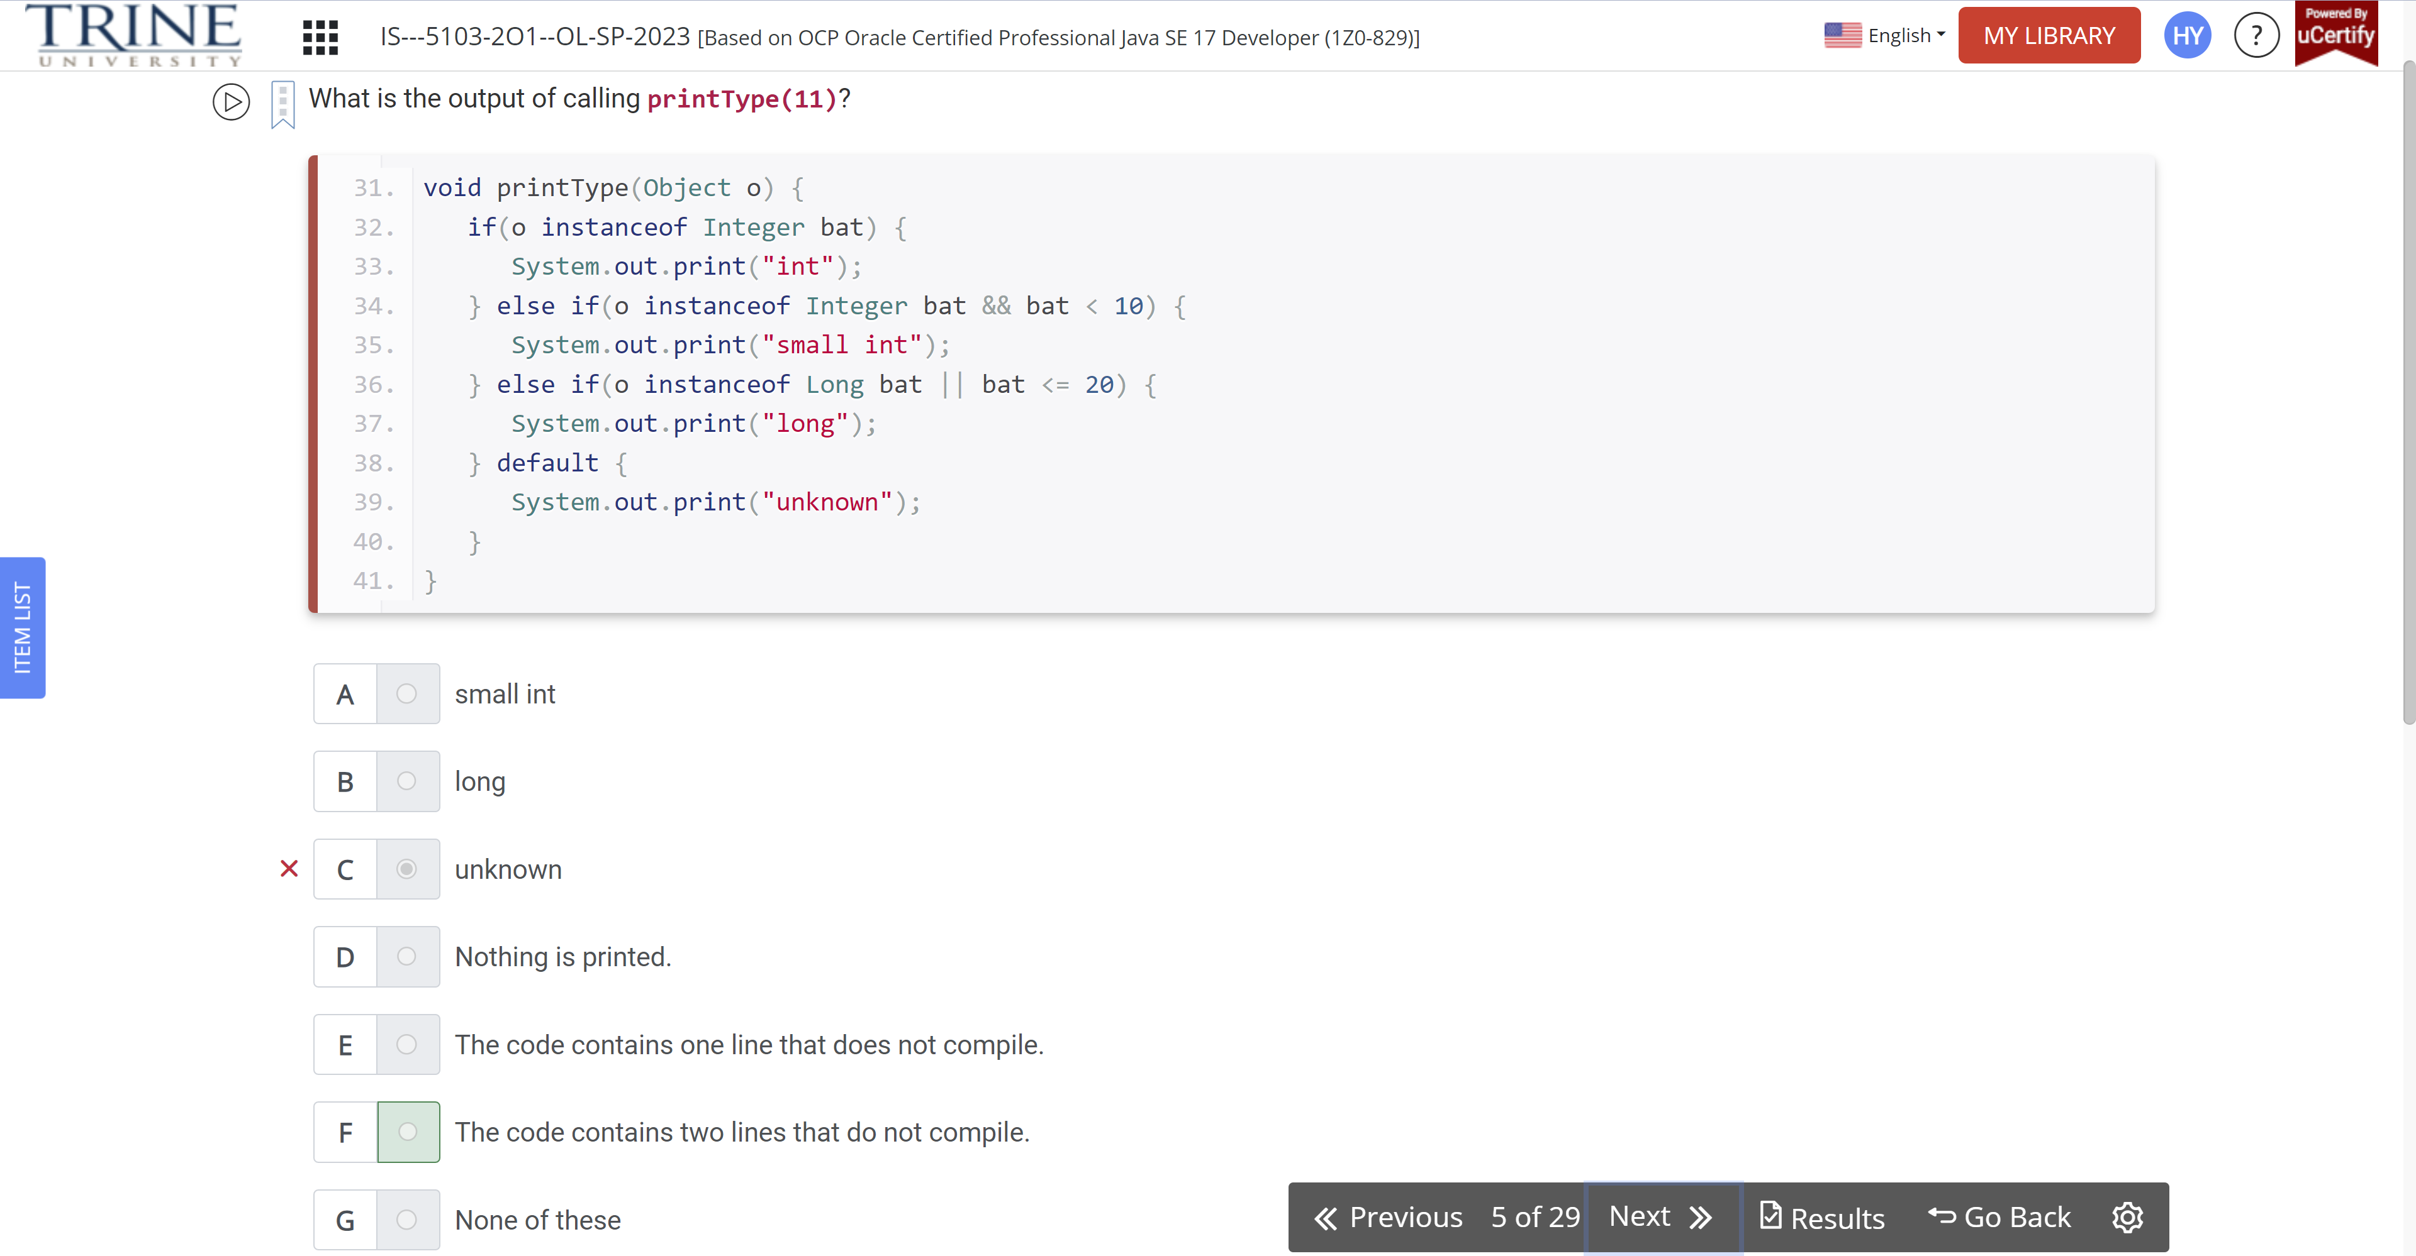

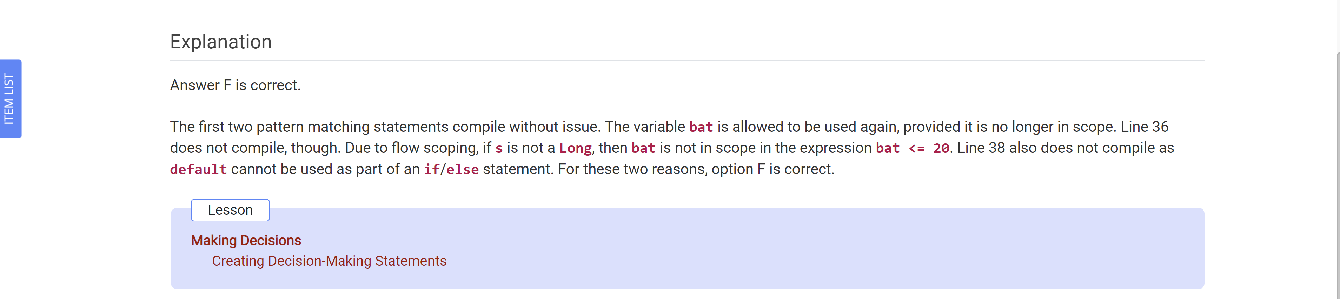

What is printed by the following code snippet?

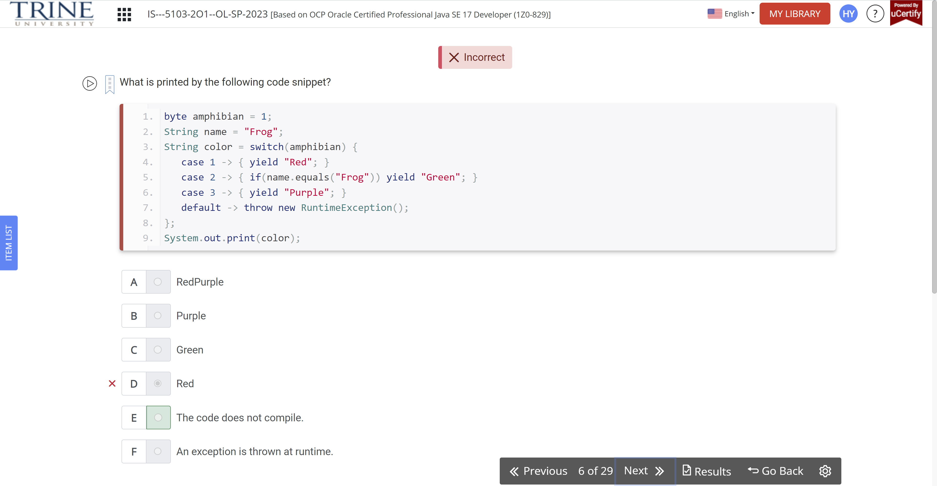

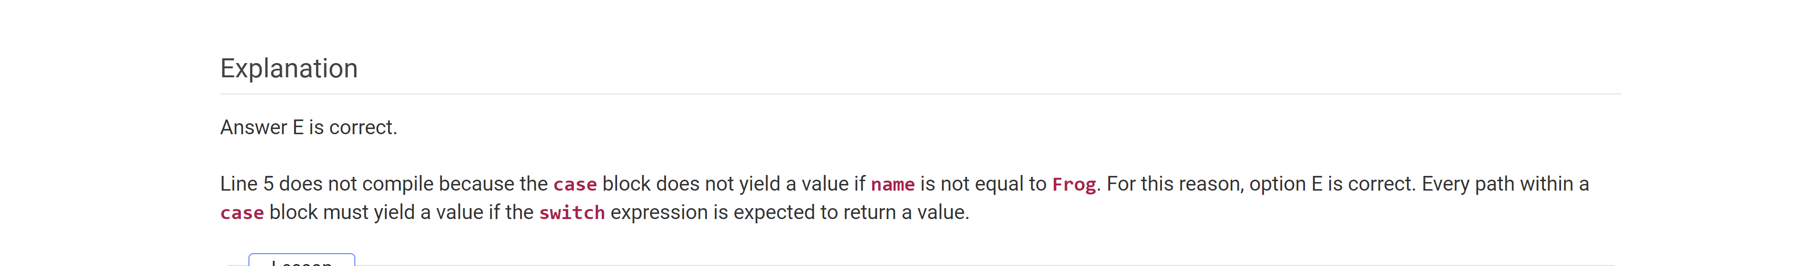

Which statements about decision structures are true?

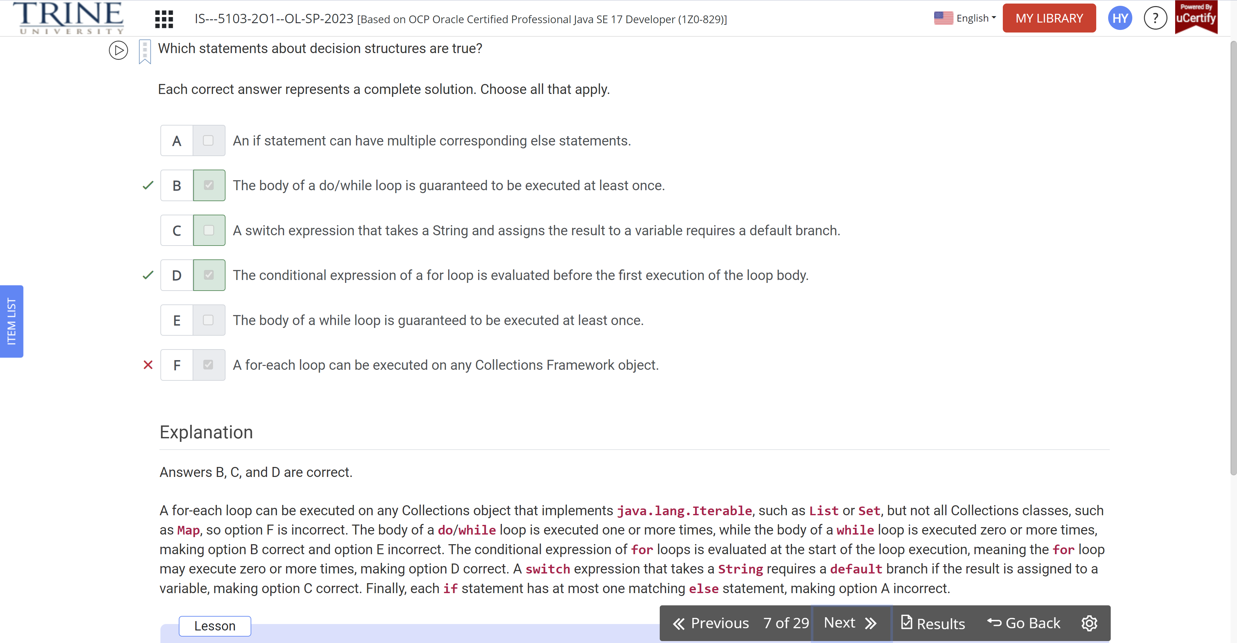

What is the result of the following code snippet?

Int sing = 8,

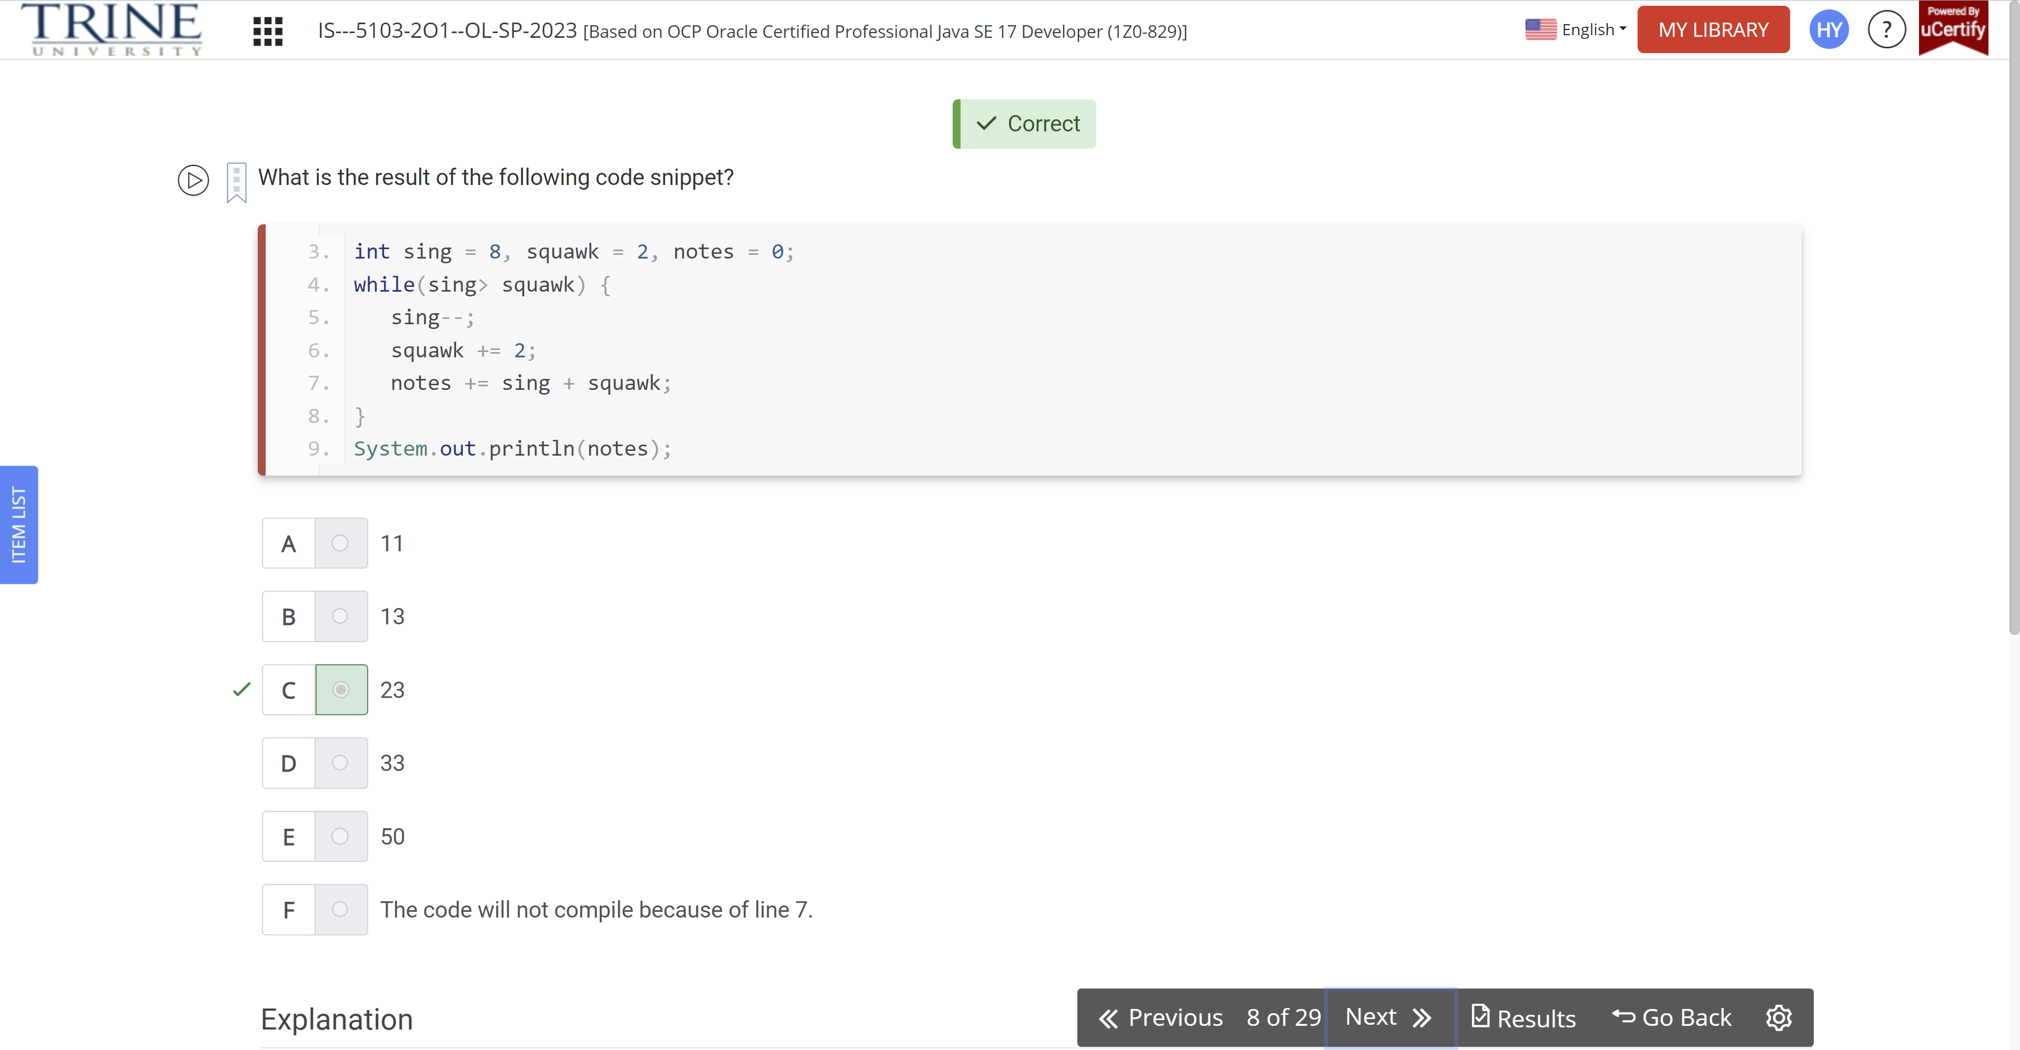

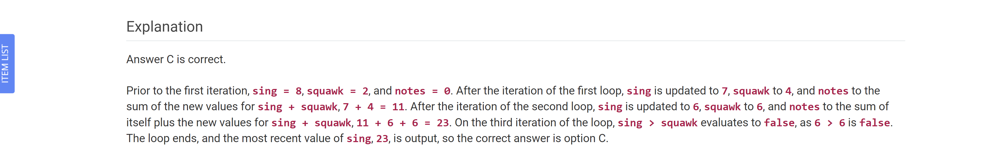

Which of the following are possible data types for friends that would allow the code to compile?

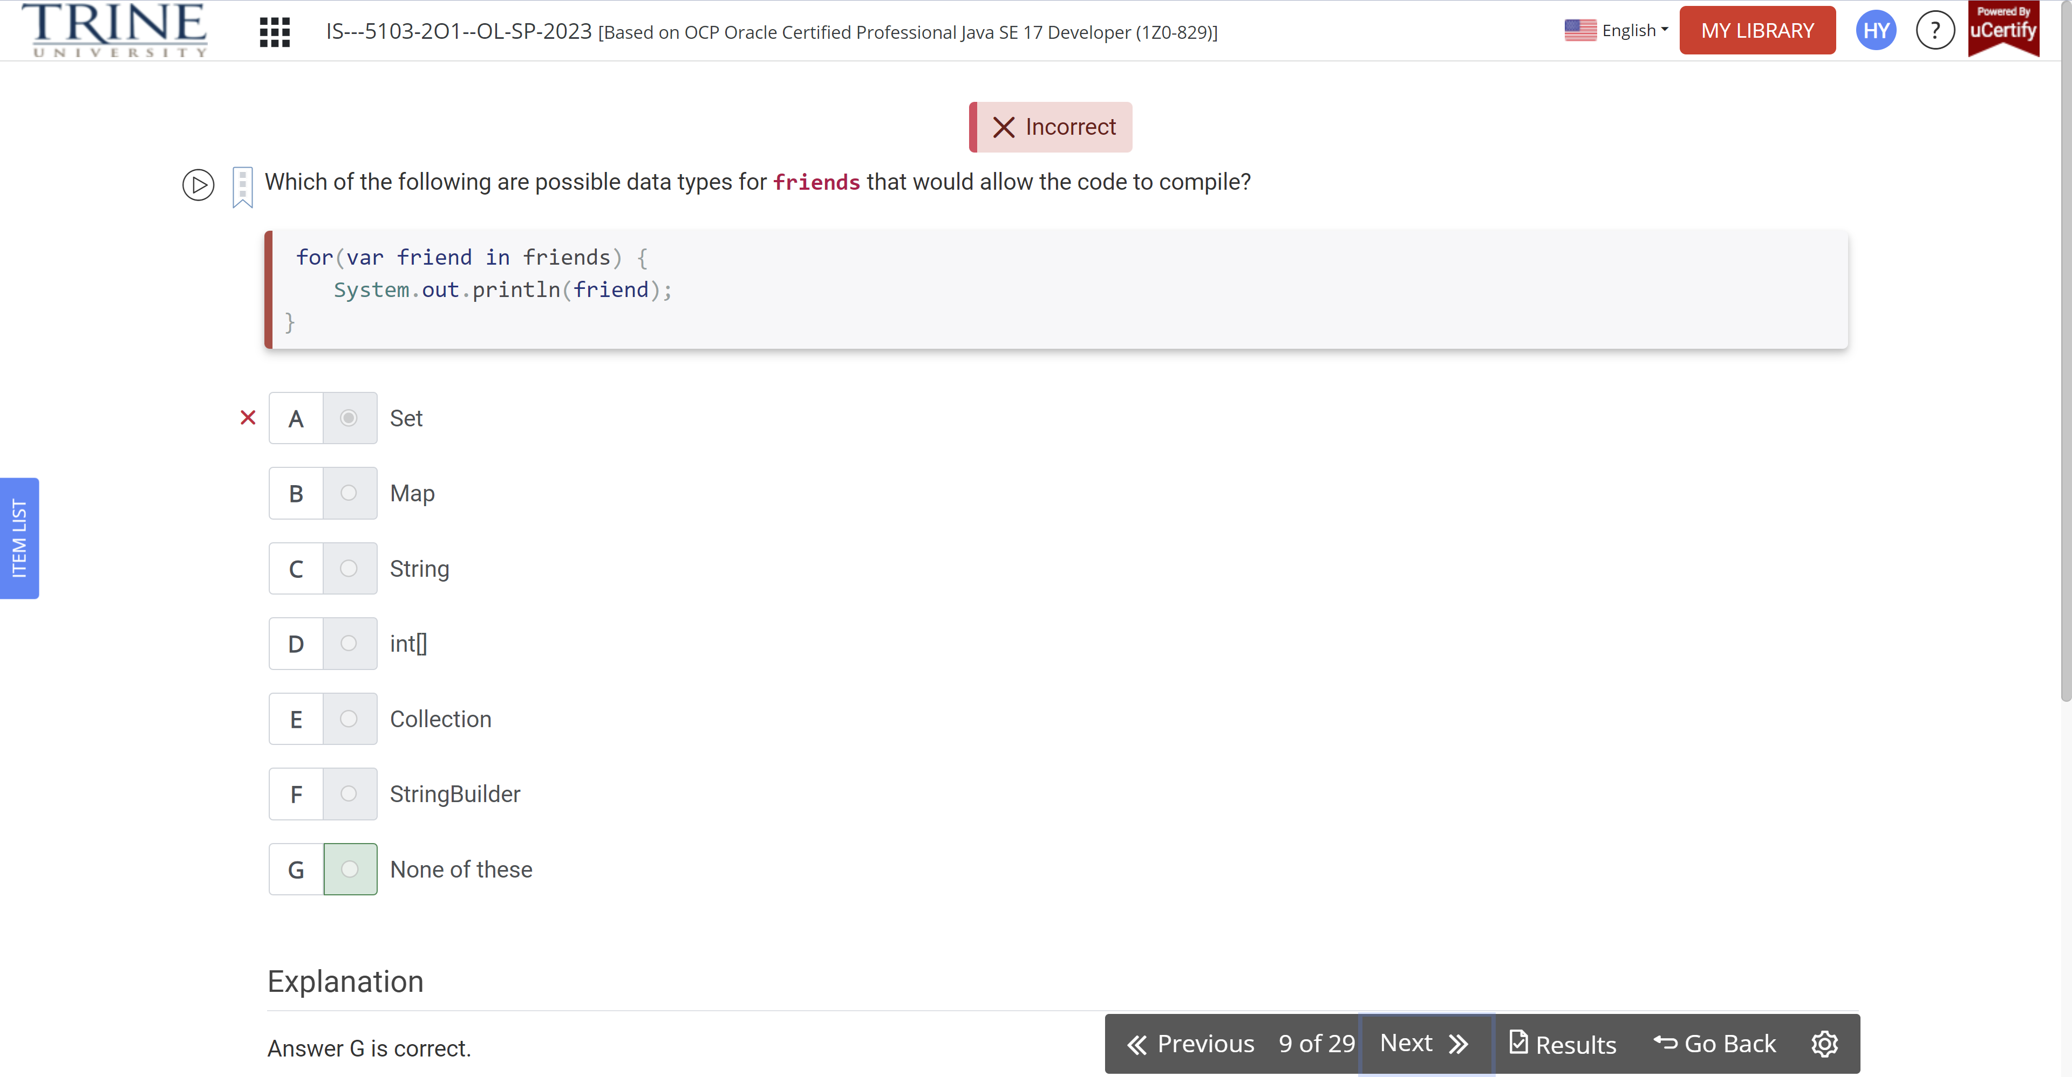

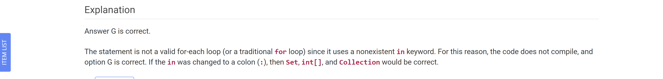

What is the result of the following code snippet?

Final char a = …

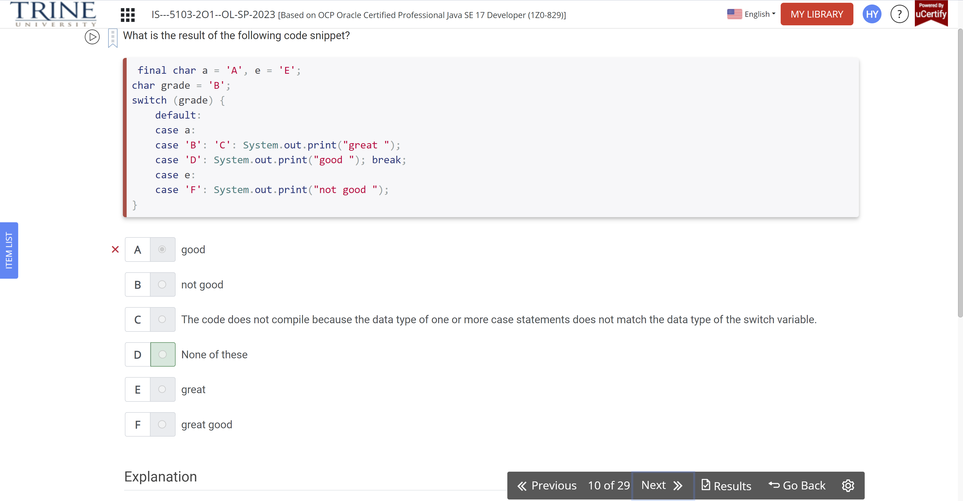

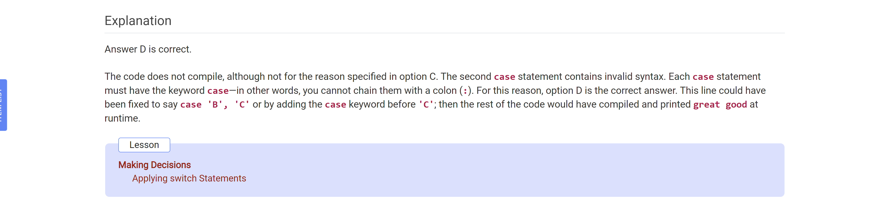

What is the output of calling printLocation(Animal.MAMMAL)?

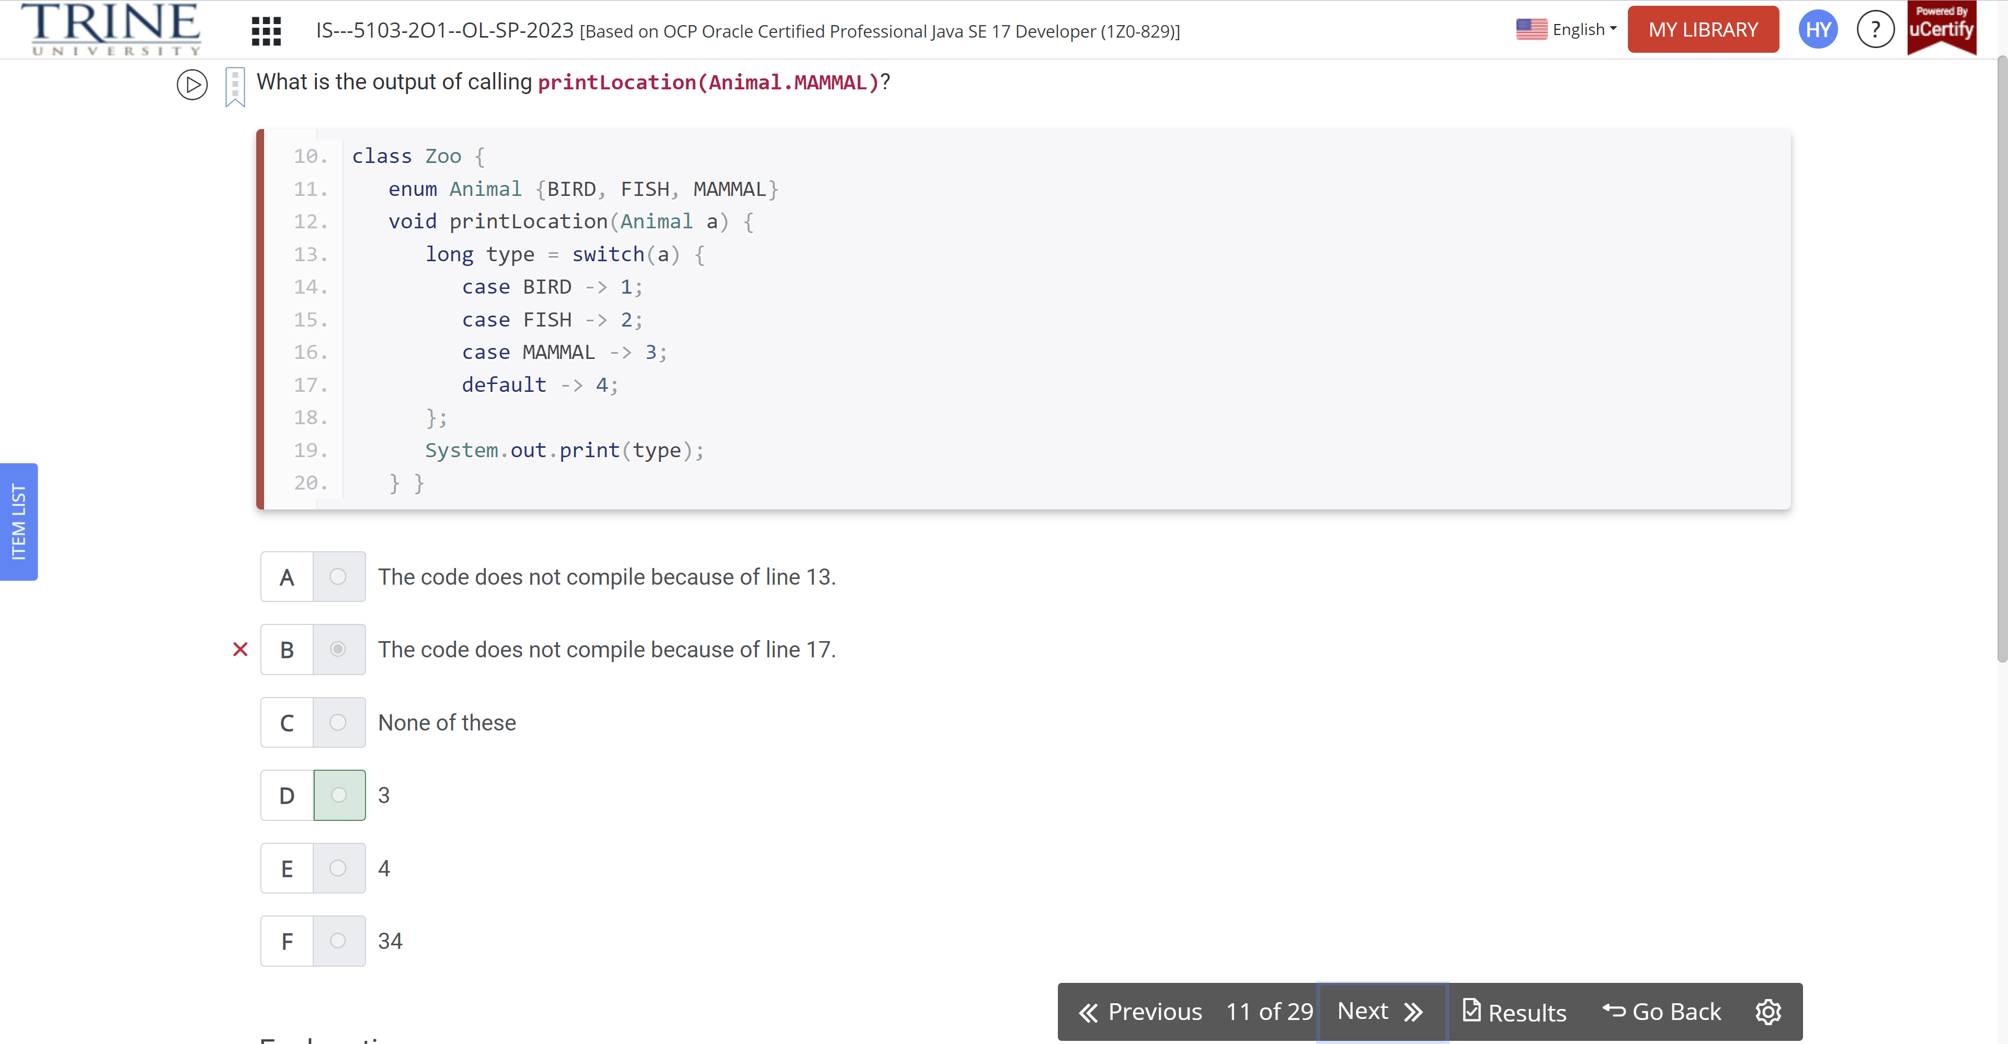

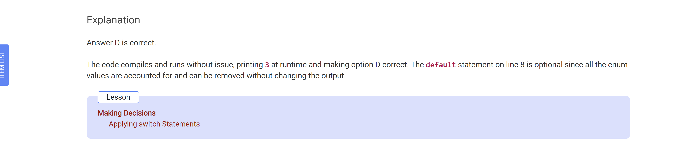

Which of the following data types can be used in a switch expression?

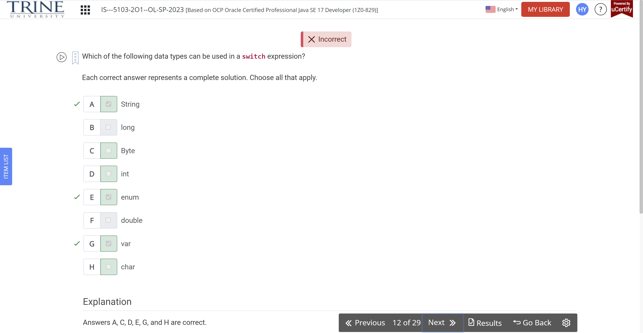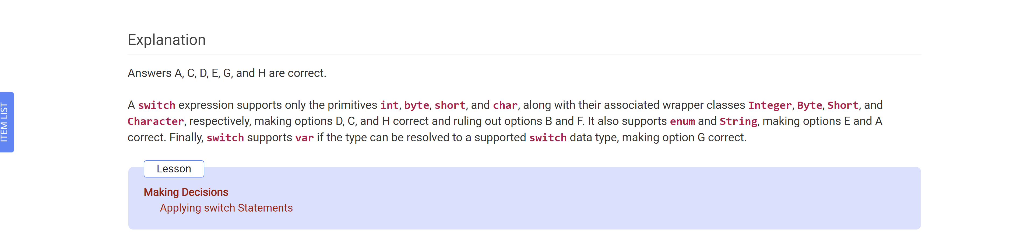

What is the output of the following code snippet?

Int tailfeather = 3

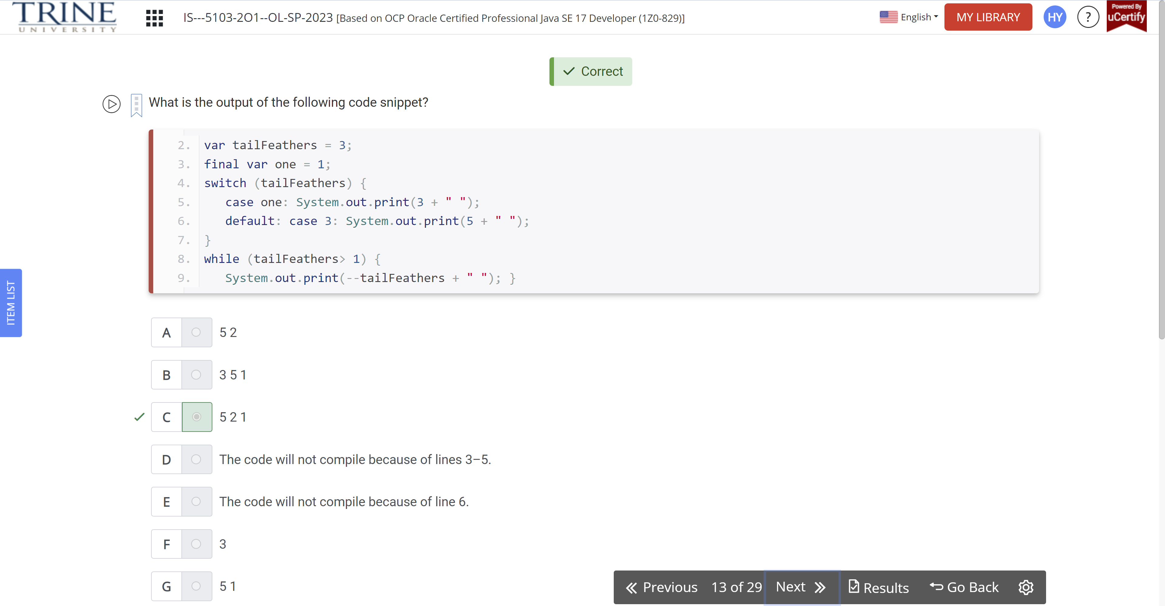

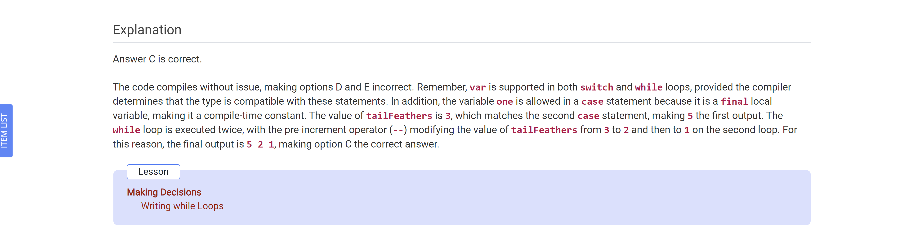

What is the output of the following code snippet?

Int temperature = 4;

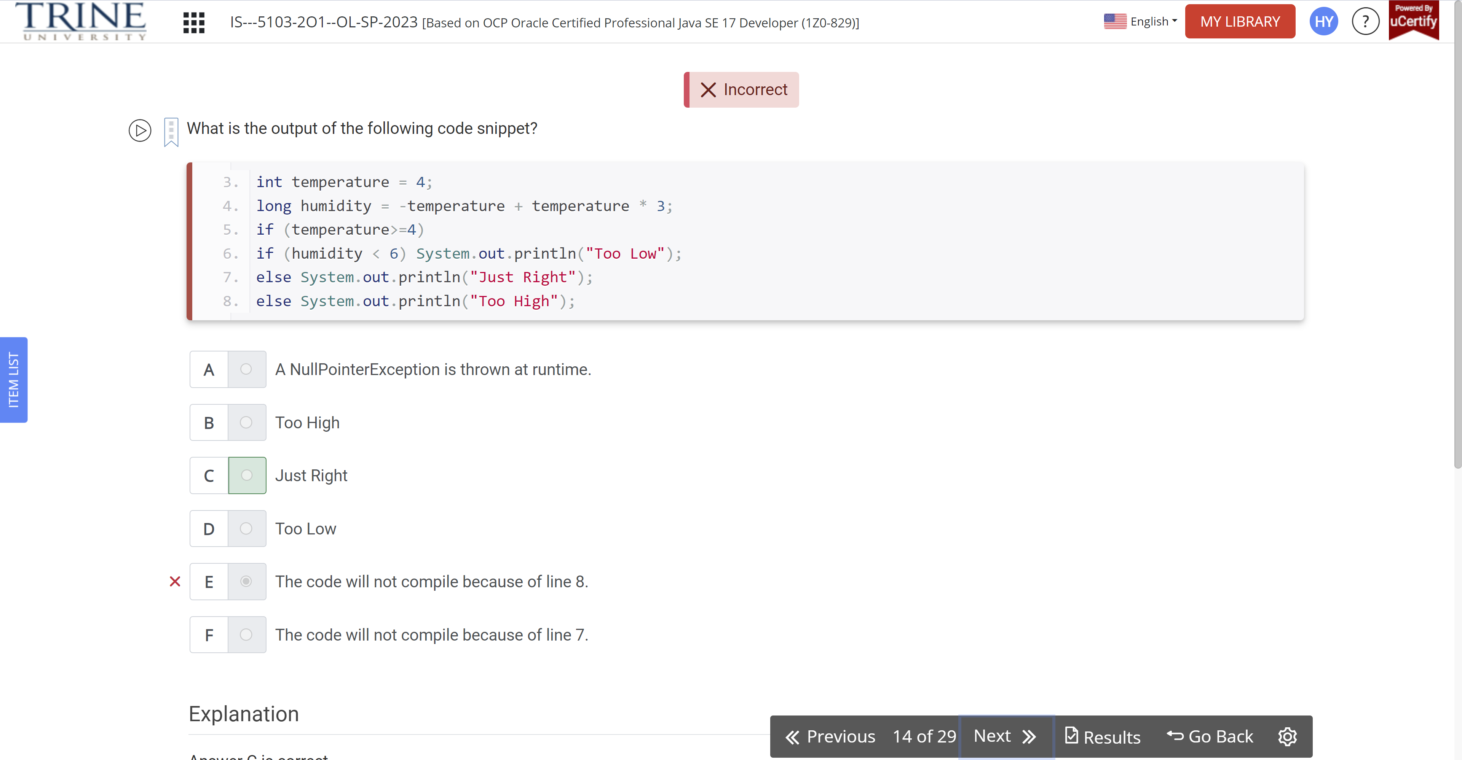

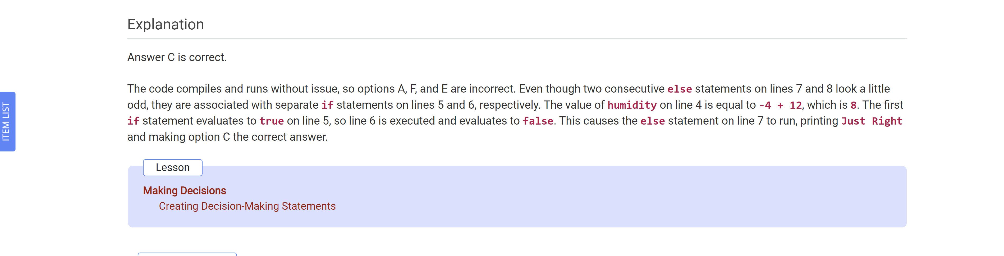

What distinct numbers are printed when the following method is executed?

countAttendees()

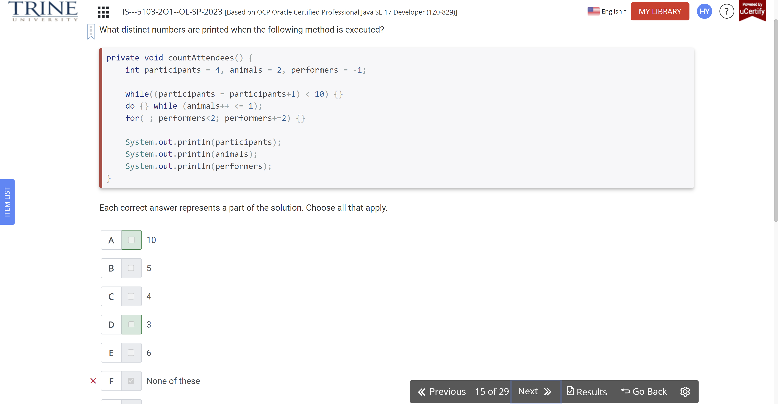

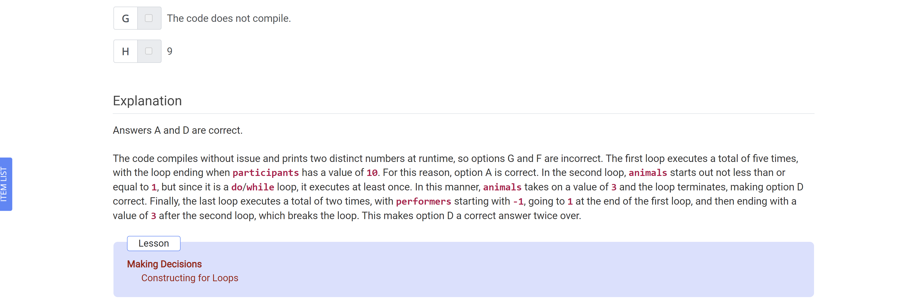

Given the following array, which code snippets print the elements in reverse order from how they are declared?

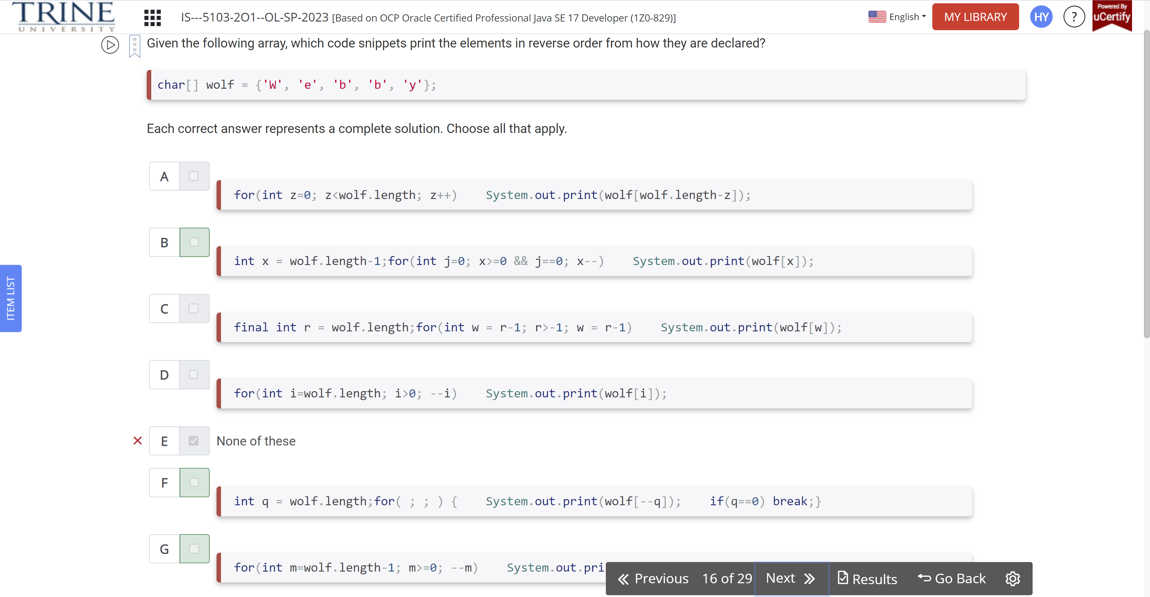

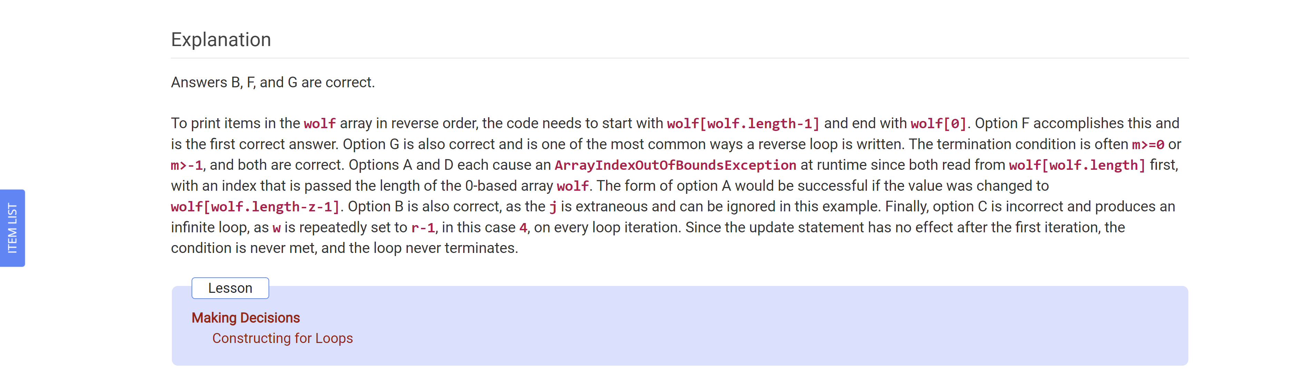

What is the output of calling getFish(“goldie”)?

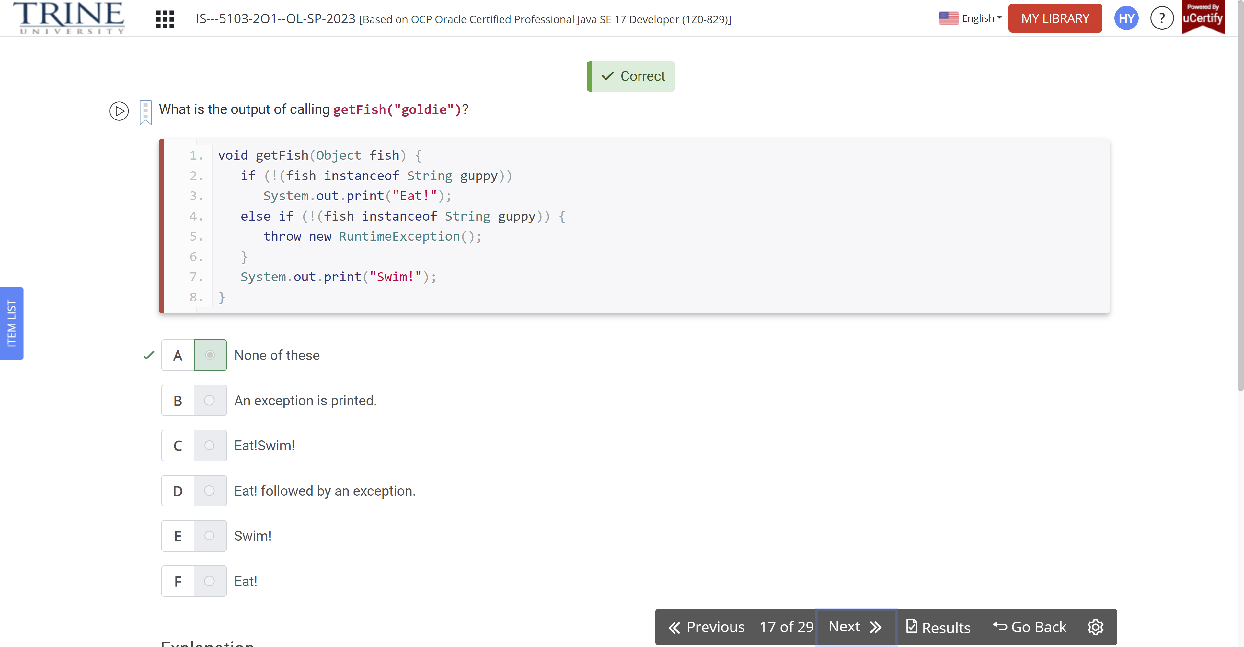

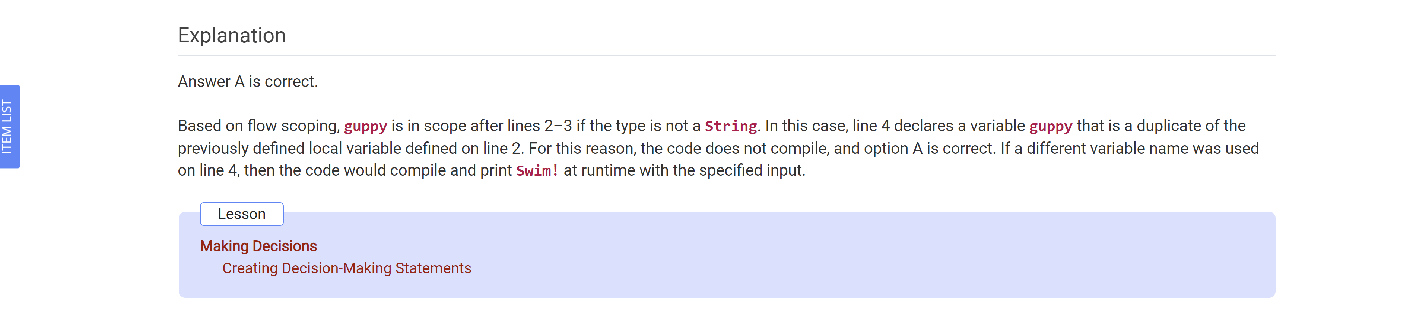

What is the output of the following code snippet?

String instrument = “violin”;

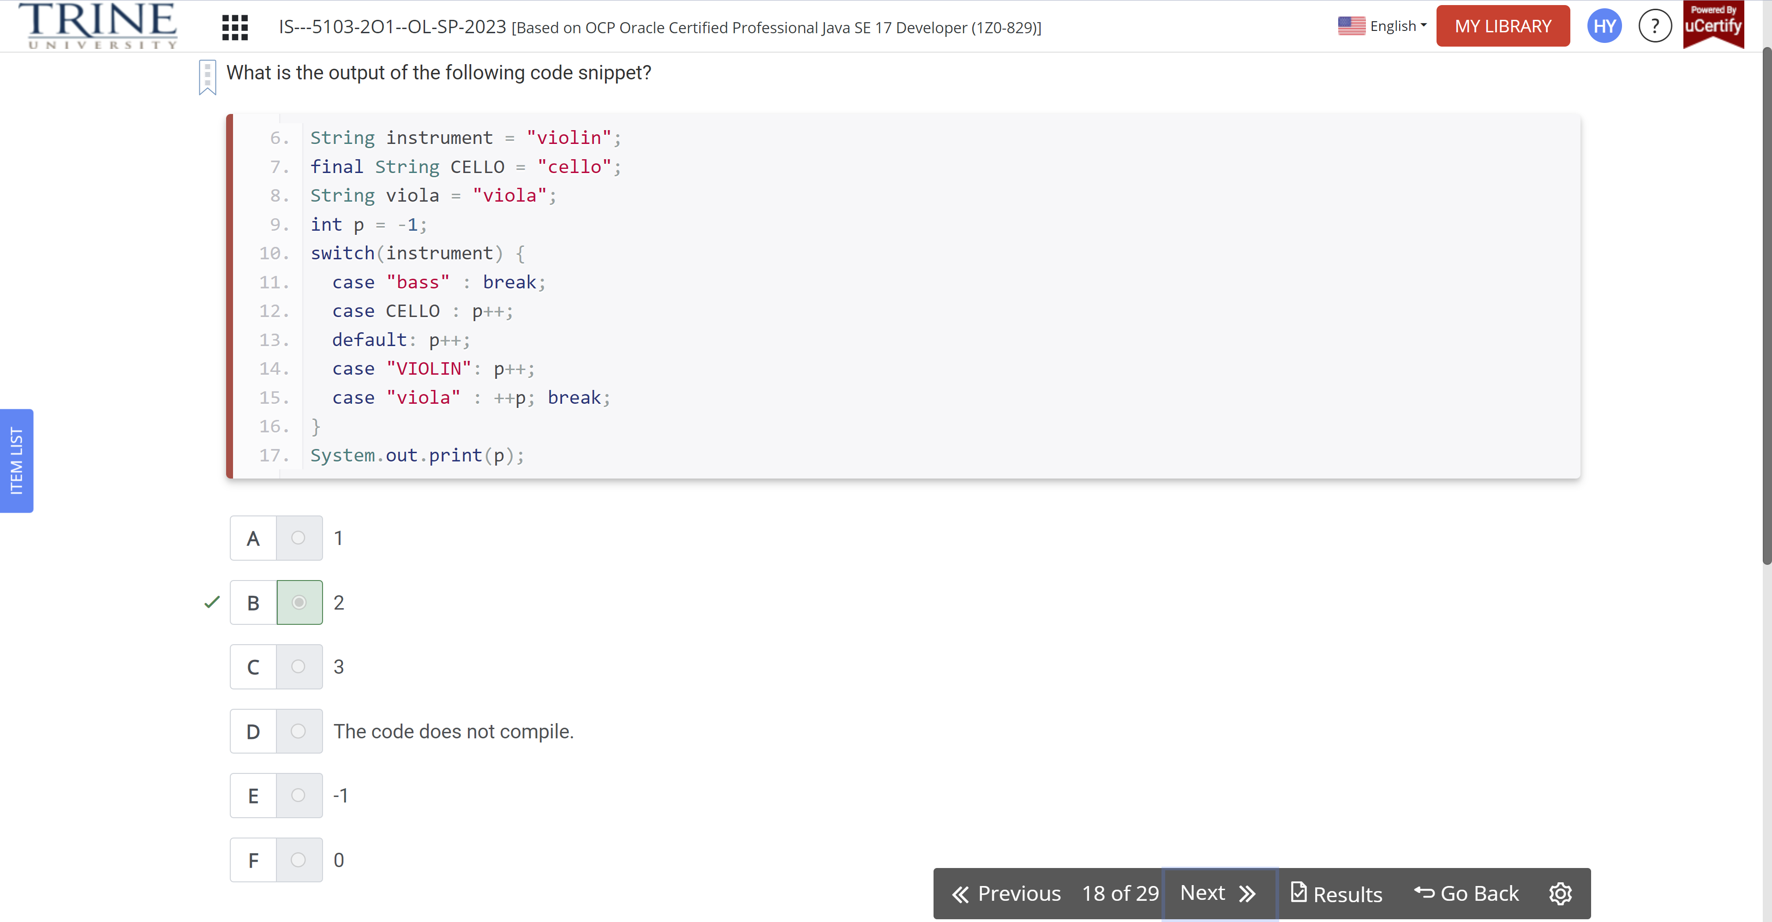

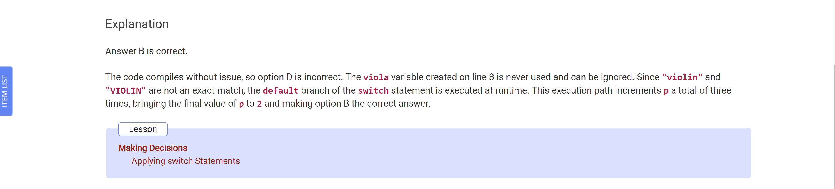

What is the output of the following code snippet?

Int w = 0, r = 1;

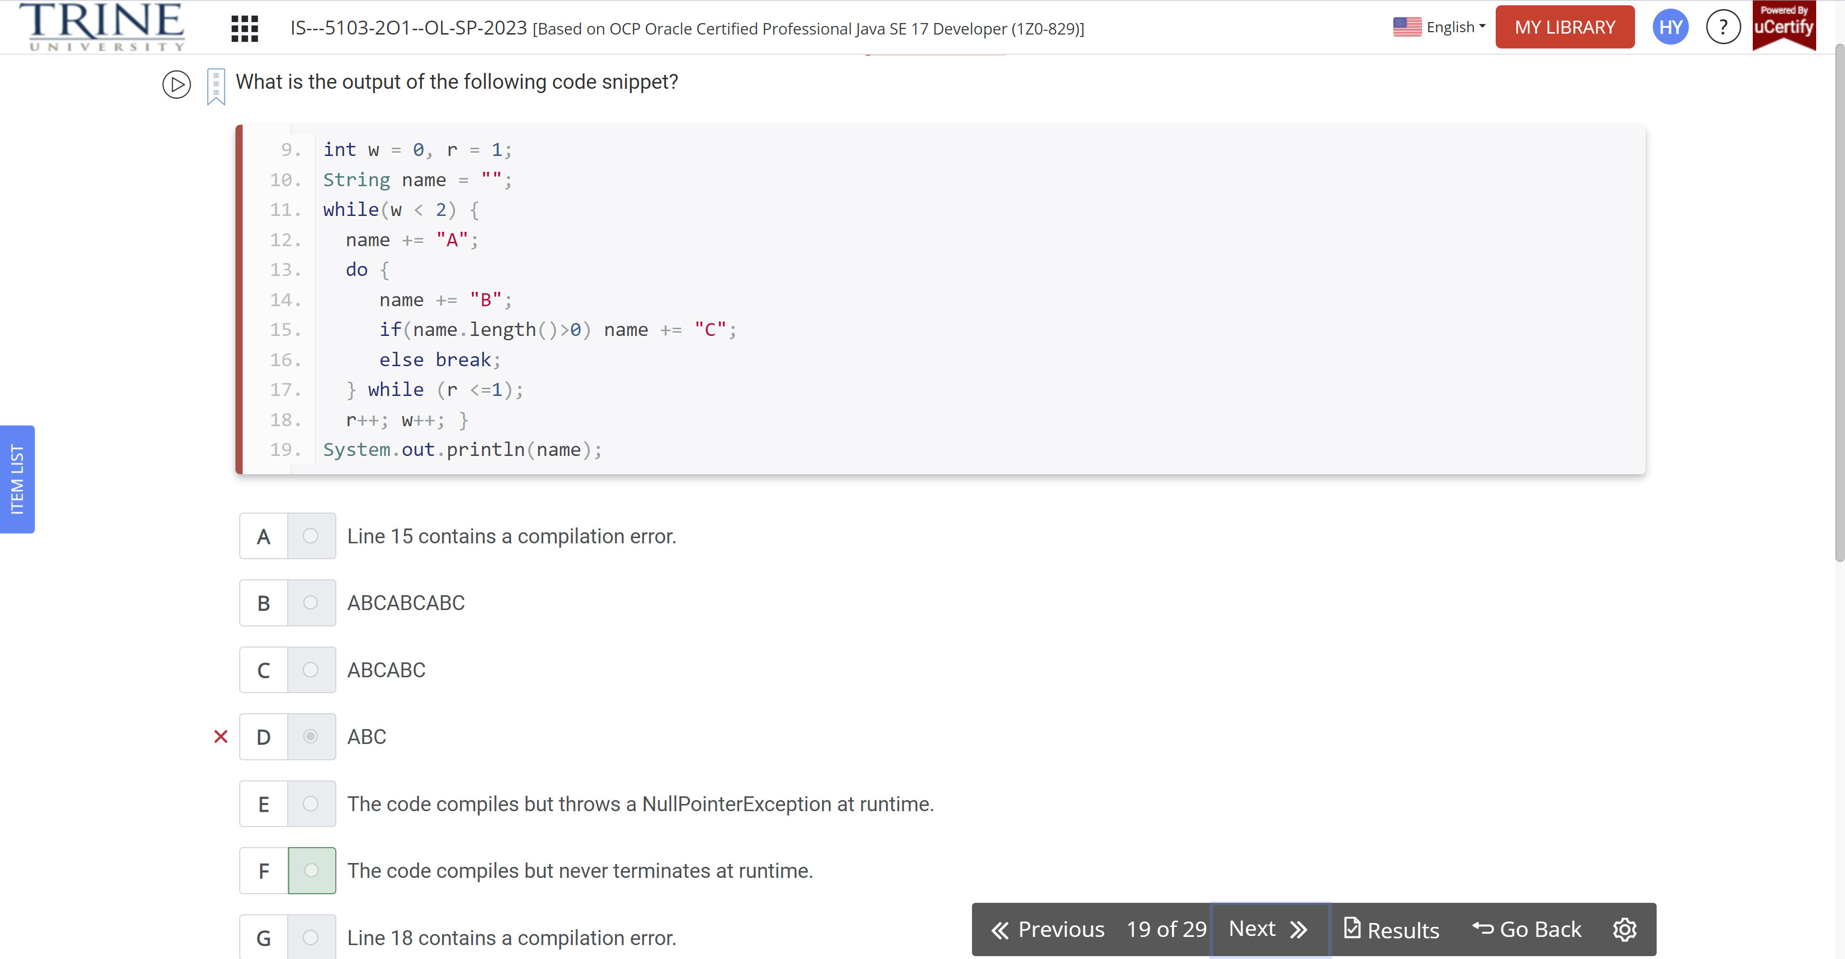

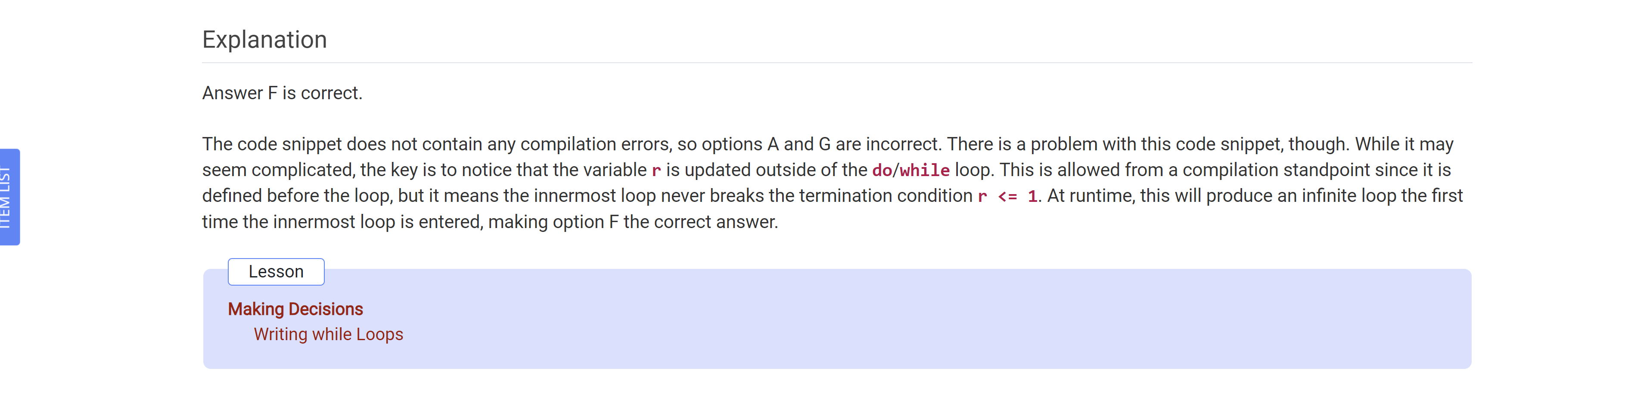

Which statements, when inserted into the following blanks, allow the code to compile and run without entering an infinite loop?

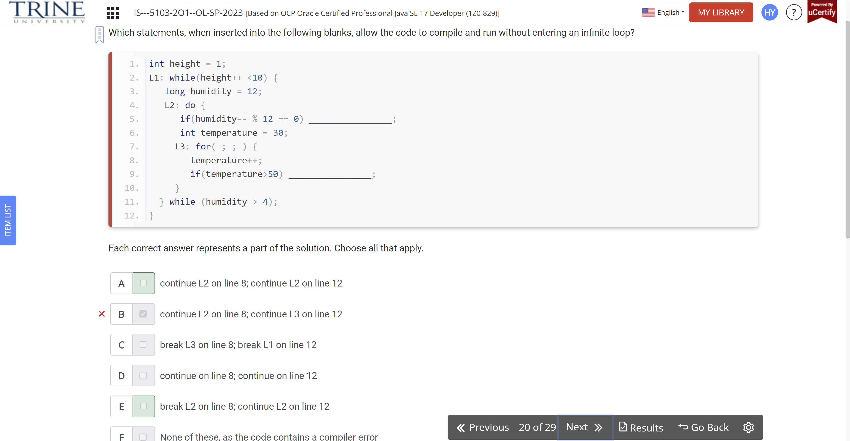

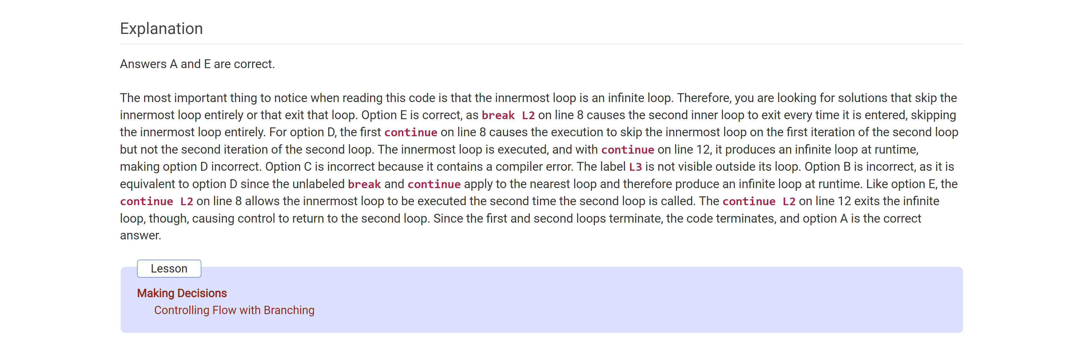

What is the output of the following code snippet

Boolean keepGoing = true;

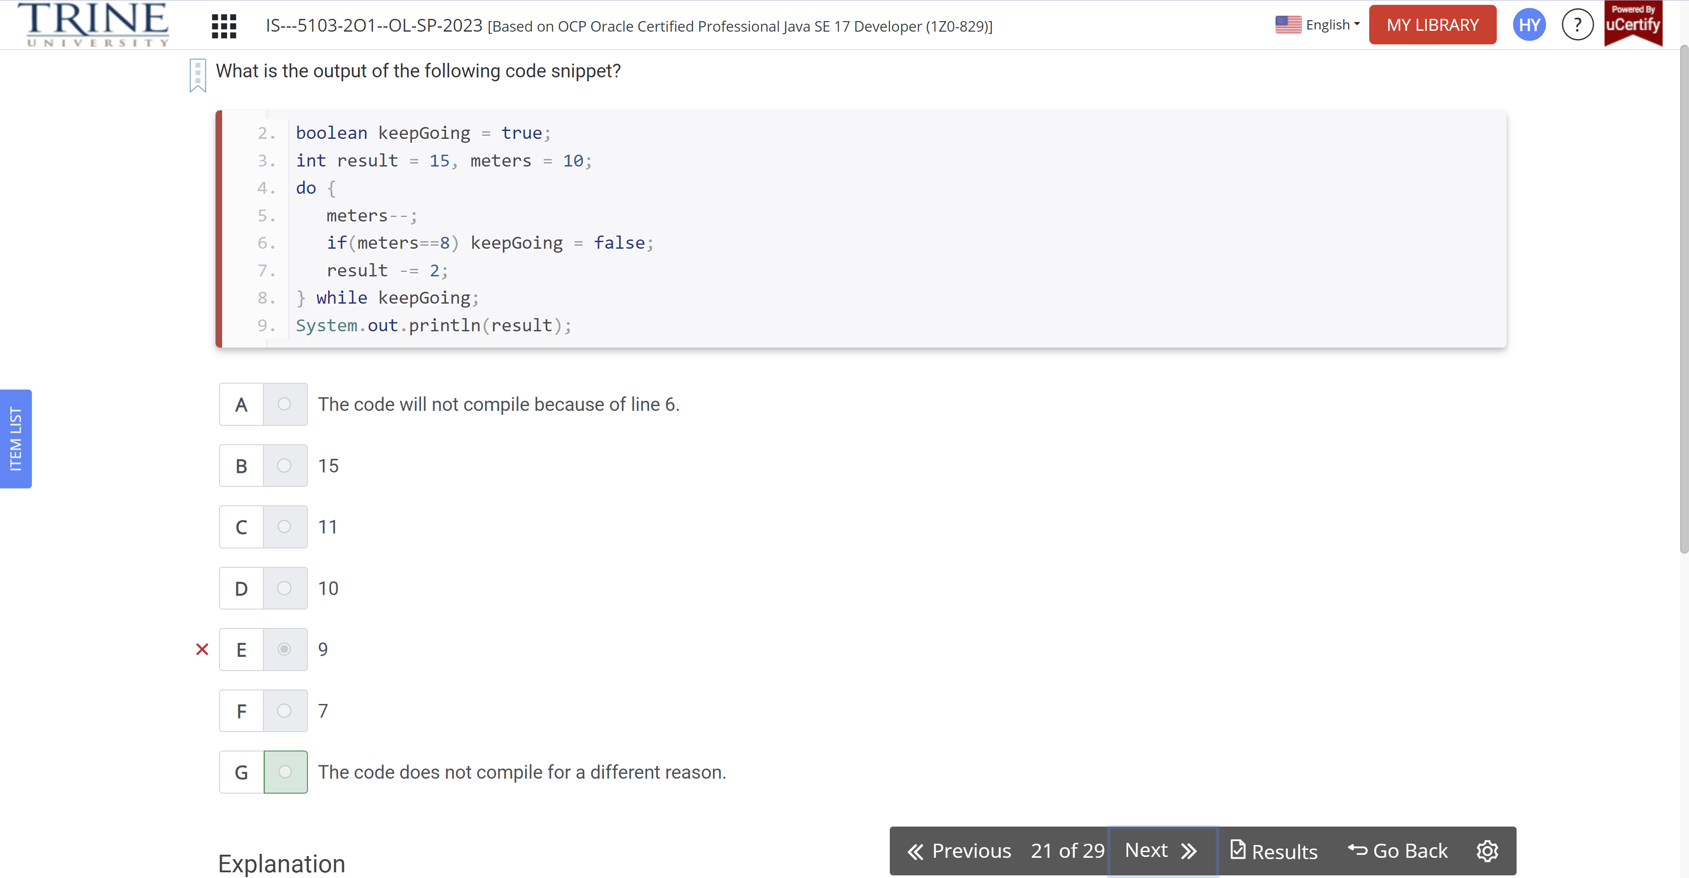

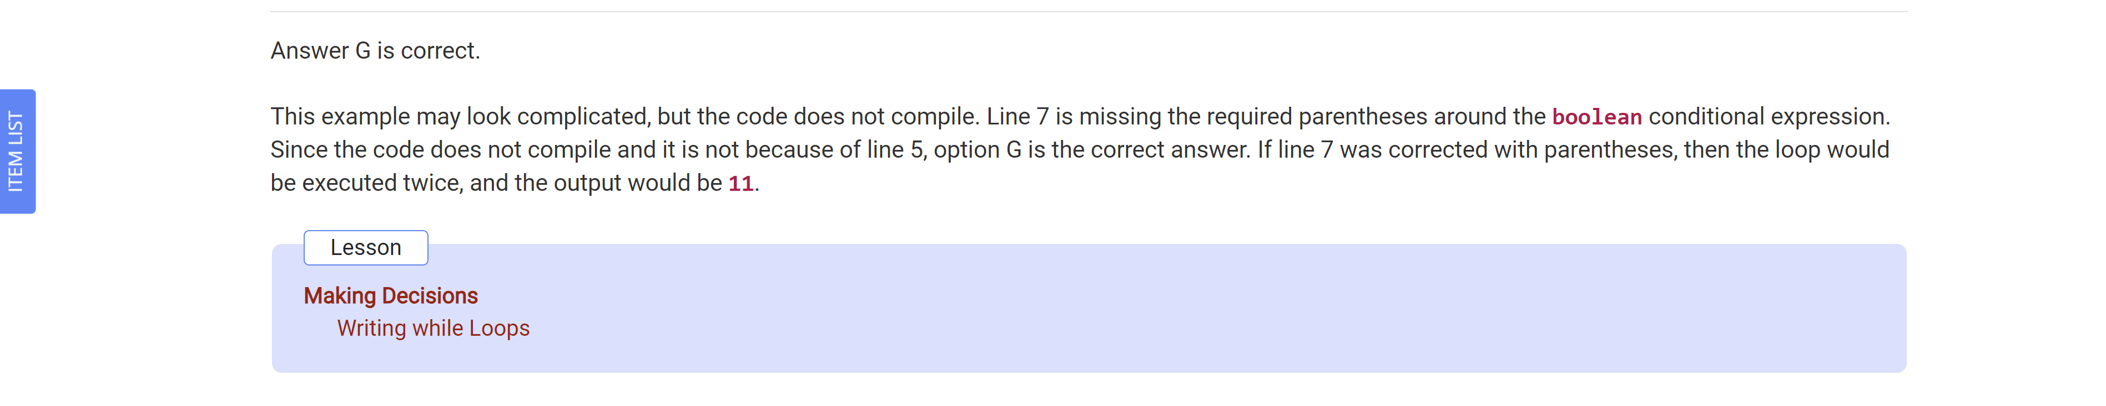

A minimum of how many lines need to be corrected before the following method will compile?

Void findZookeeper(Long Id)

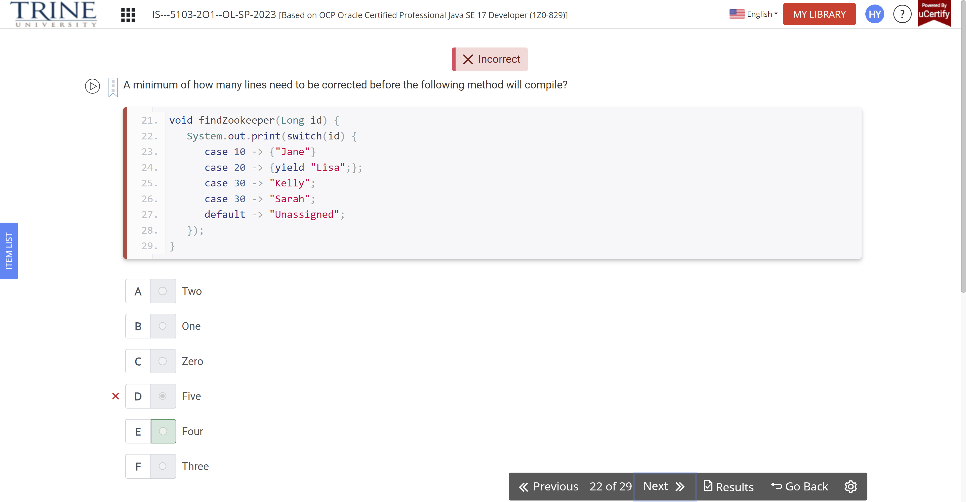

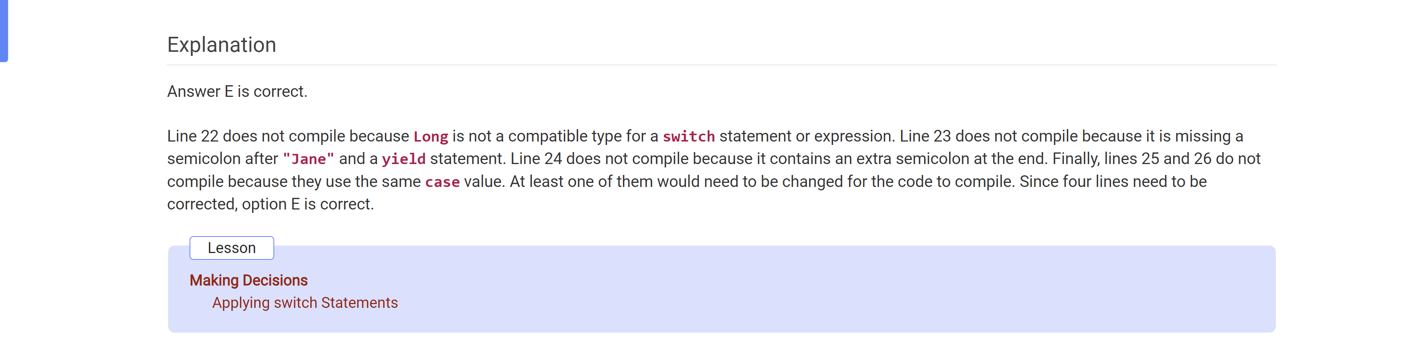

Assuming weather is a well-formed nonempty array, which code snippet, when …

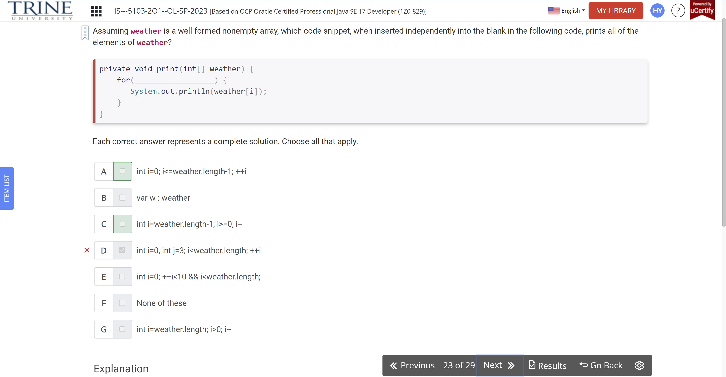

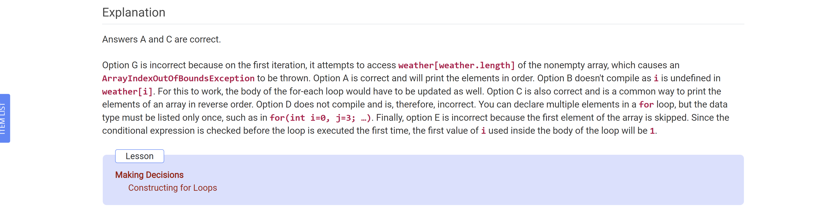

What is the output of the following code snippet?

Int penguin = 50, turtle = 75;

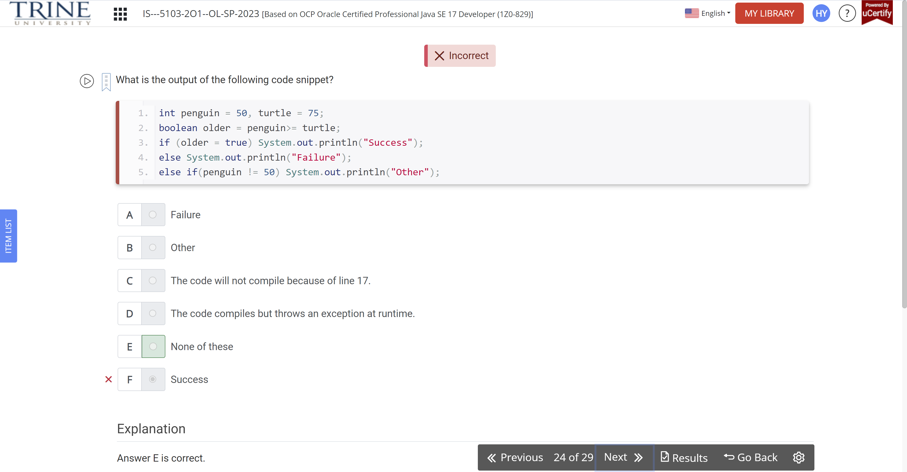

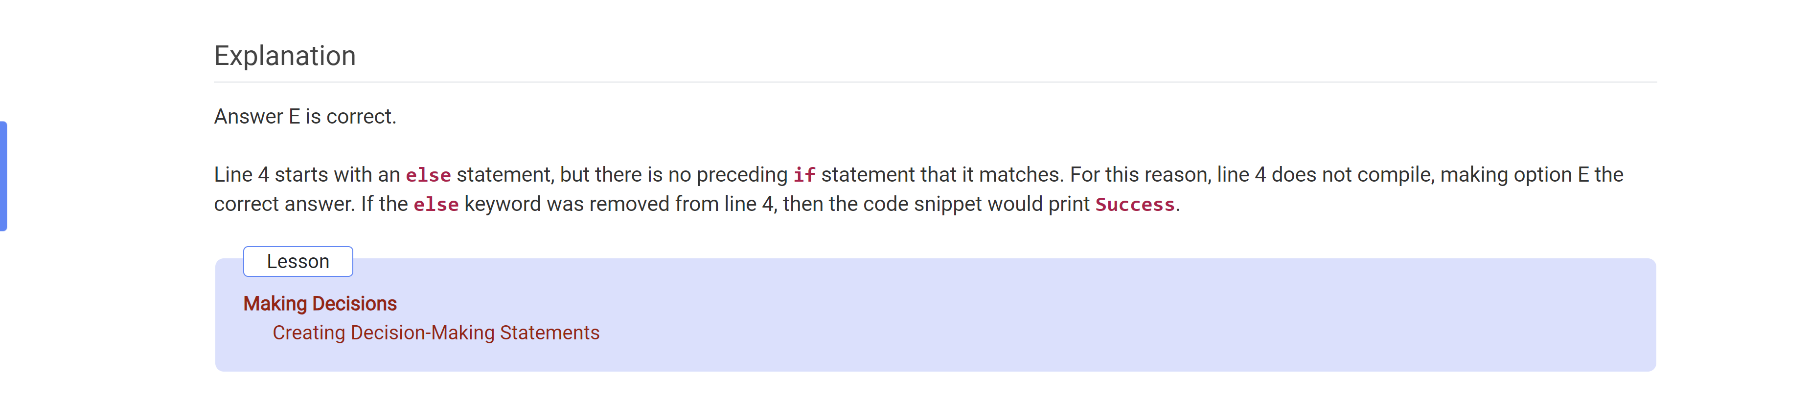

Which of the following data types are permitted on the right side of a for-each expression?

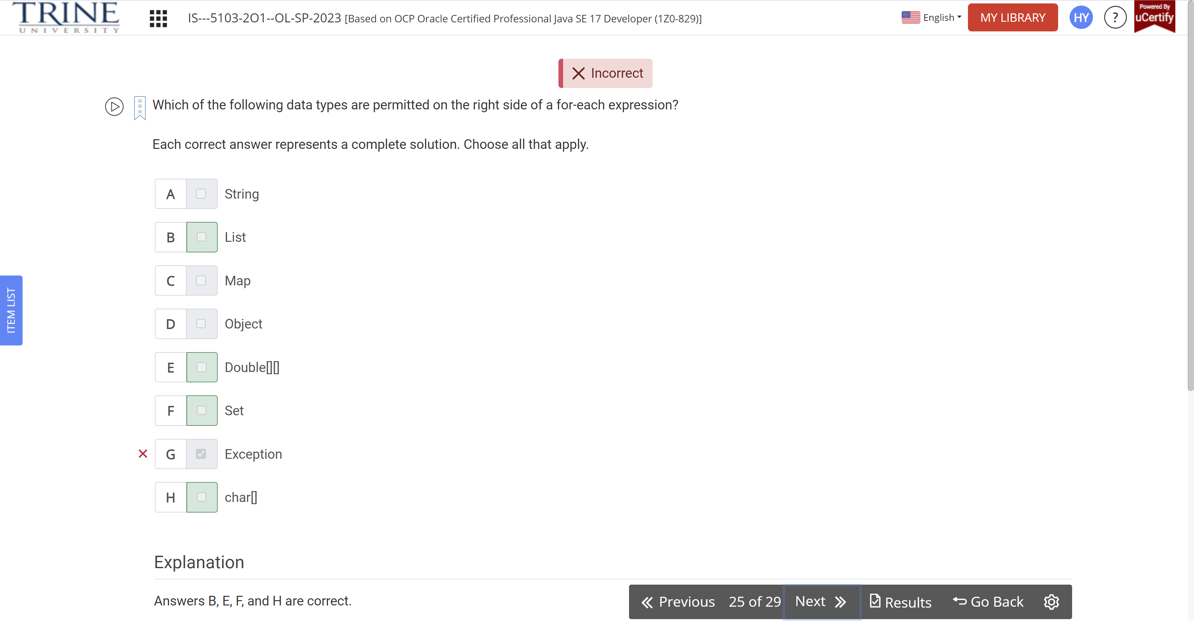

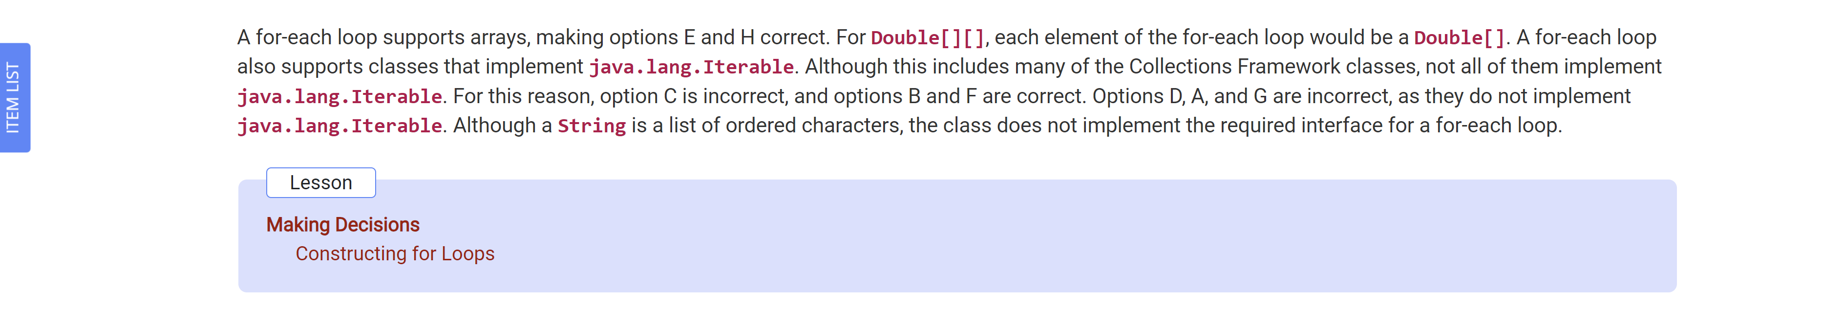

What is the output of calling printReptile(6)?

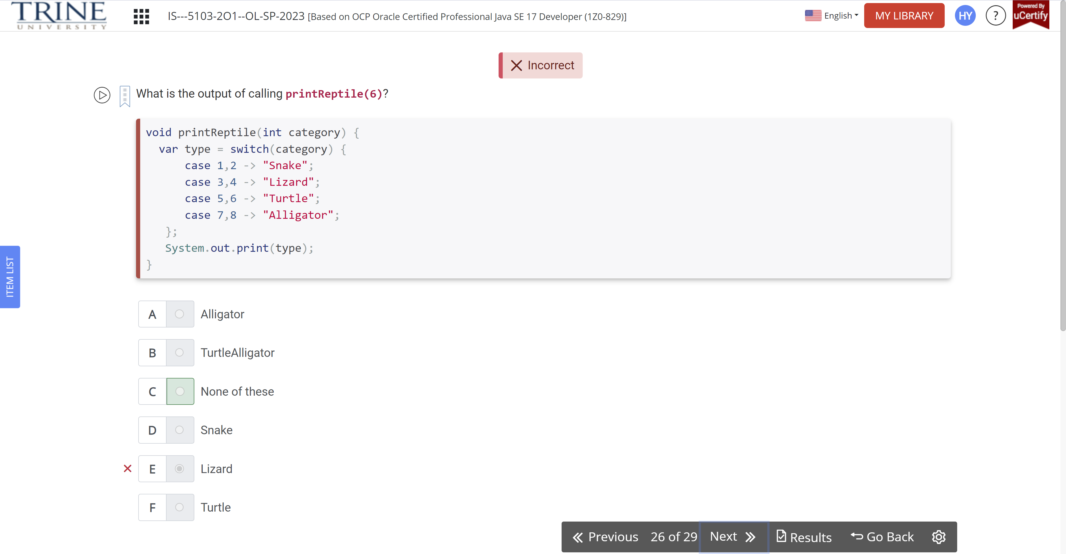

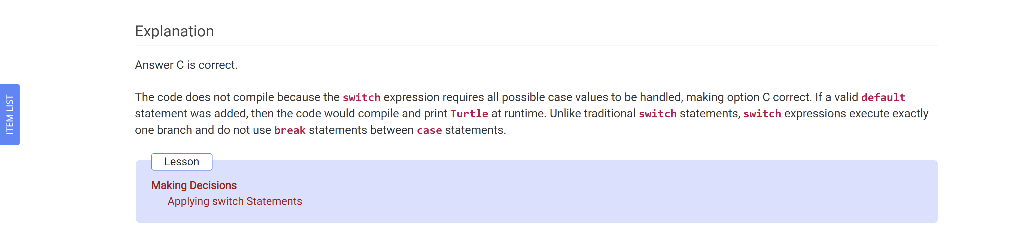

Given the following method, how many lines contain compilation errors?

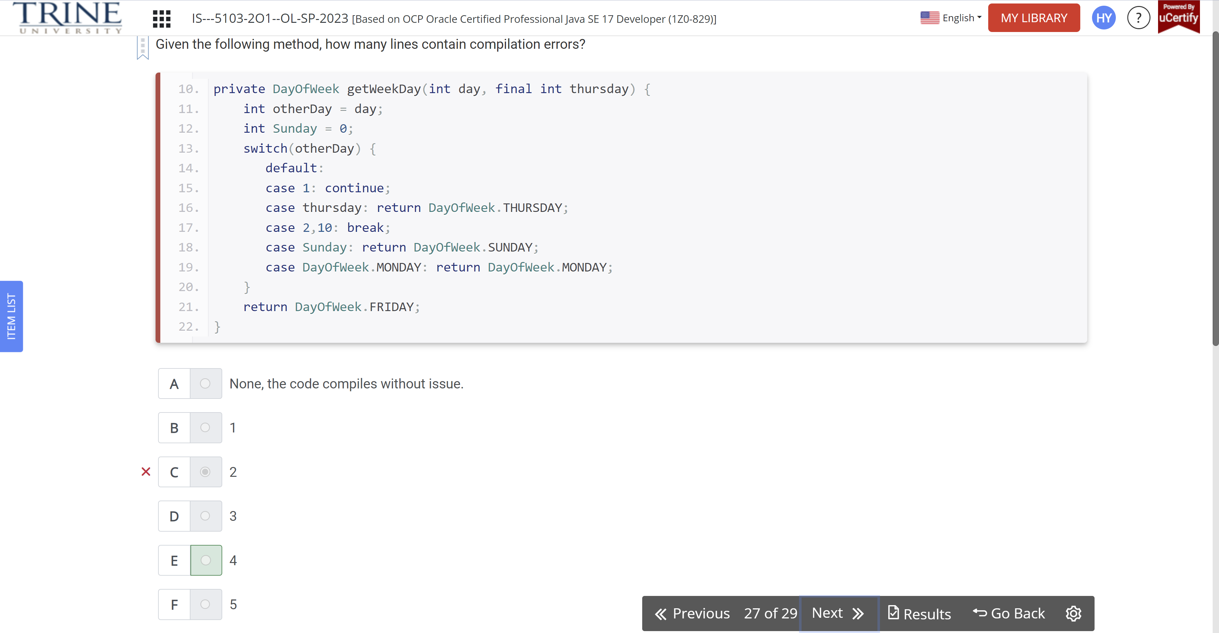

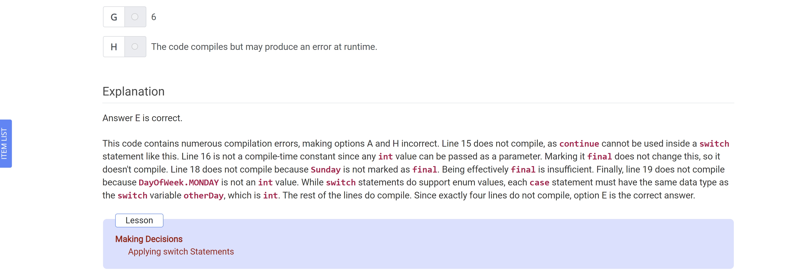

Which statements about pattern matching and flow scoping are correct?

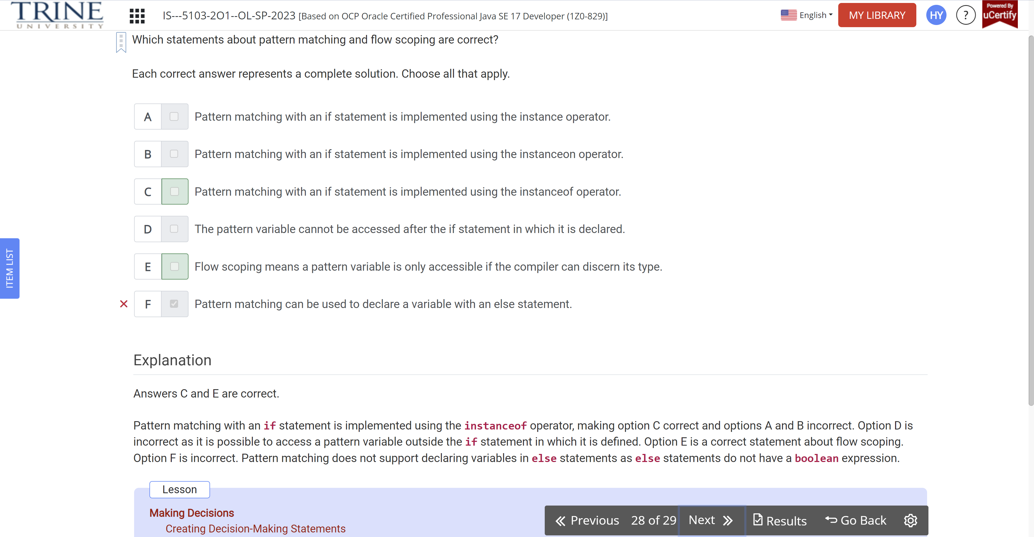

What is the output of the following code snippet?

List<Integer> myFavoriteNumbers

